Project Summary Tab
The information on this tab will be completed by the Best Buy Store Experience Project Manager. This information will be used for internal Best Buy cross-functional teams to reference.
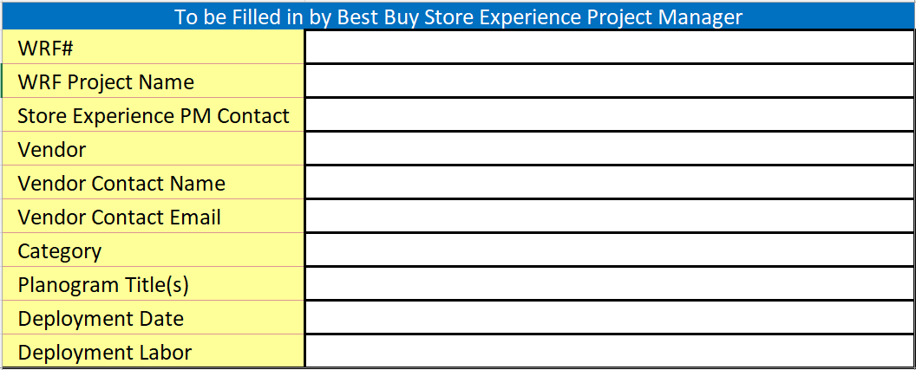
- WRF#
  - WRF number for the project that will be occurring for the display/parts list on this form

- WRF Project Name
  - Enter the same Project Name entered when creating the WRF

- Store Experience PM Contact
  - BBY SEPM contact for the Project

- Vendor
  - Vendor the Project is for

- Vendor Contact Name
  - Contact name of the person representing the Vendor for the Project

- Vendor Contact Email
  - Email address of the person representing the Vendor for the Project

- Category
  - BBY Category the Project is for (Appliances, Computers, Home Theater, Smart Home)

- Planogram Title(s)
  - List the name of the Planogram(s) that the display(s) will be set on

- Deployment Date
  - Date the display/parts will set in store

- Deployment Labor
  - Best Buy Labor = Blue Shirts (Red Label)
  - 3PL = Third Party Merchandising (Blue Label)
  - VDT = Visual Deployment Team (Green Label)

BBY VPP Form Tab
The BBY VPP Form tab will be completed by the Vendor and requires all the columns to be filled out with the requested information for the Display(s) and Part(s). The intent of the VPP handoff form is document each part that makes up a display (Full Kit). This will be a living document that will be updated for the life of the display.
- Each Plangram title should show the Master Kit part used on that Planogram. Begin with creating a Master Kit part for each unique version of a display needed. This part should encompass the entire display. This should be entered into Row 3, and listed as a line item in row 5 through 9
- Individual parts or Refresh kits should be entered in line 11 and after. Each replaceable part should be able to be reordered.
- The columns with gray header cells are to be completed by the Vendor.
- The vendor/supplier will provide part numbers for all part types (including graphics)
- We require a full kit part number for future ordering of an entire display – i.e. for new store openings, future expansion of a display
- Common parts may be used on multiple displays and can be noted by selecting all the Kits they would be in when completing the form
- Part number for any graphics should be printed on lower right corner of graphic in 10pt. The vendor is responsible for creating part numbers for graphics.
- Any current part that is being removed should be listed as an Obsolete
- The main display should be labeled on the back with the part number per Display Labeling guidelines
*NOTE* When parts of a display cannot be re-ordered for R&M, the complete display will be ordered.
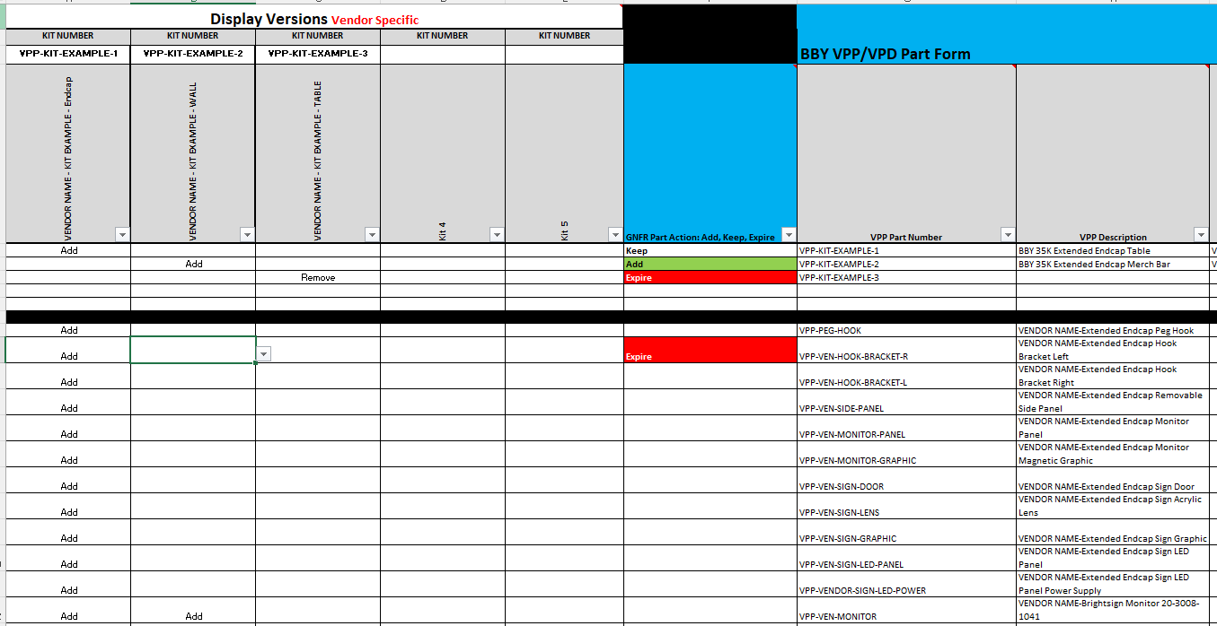

- Display Version(s)
  - Vendors will enter a Full Kit part number in Row 3. The Full Kit number will be the part that if an order is placed the kit that is sent will be everything required to take a clear area to a fully functional display. The Full Kit part number will remain the same for the life of the display and should be updated with all the current elements based off any refresh kits or updates that take place for the display.
  - The form will allow for 5 total Kits to be entered depending on the number of display versions. If more than 5 are needed, you will need to reach out to your BBY Store Experience Project Manager
  - We recommend noting “Full Kit” in the description to allow for additional visibility in our Item Library
  - You will fill in the parts that make up the kits starting on Row 11

- VPP Part Number
  - The Vendor will provide part numbers for all part types including graphics.
  - The request from Best Buy is that all part numbers provided for a display include “VPP-“ in front of them
  - All part numbers that include letters need to be UPPERCASE.
  - Limit part numbers to no more than 40 characters (NO SPACES).
  - No special characters can be used except for the “-“ (minus/dash)

- VPP Description
  - The Vendor will provide a recommended part description for all part types and kits. The intention of the part description is to provide Retail employees with a description of a part that will assist them in identifying the correct part/kit to order. Best Buy owns the final part description and may make modifications to add further clarity for the store employees & support teams.
  - The VPP kit description should be unique and specific to one kit
  - Limit part descriptions to no more than 140 characters including spaces
  - All descriptions begin with “Vendor Name-”

- Part Type
  - Select if the part is a Graphic, Content Device, Fixture or Electronic
  - This helps us track the part types through the life of the display

- Product SKU
  - If this dummy/mock represents a RETEK SKU, list the sellable SKU here

- New Part Replacing the Expired Part (if applicable)
  - list the part number replacing the part that is being expired or removed from the display. If there isn’t a new part you can note “No Replacement”

- GNFR Part Action: Add, Keep, Expire (to be completed by BBY Store Experience Project Manager)
  - This is an overall summary of the status needed for each part line
    - Add – new Kit or Part getting added
    - Keep – Kit or Part is staying on a display and will continue to be supported by Vendor
    - Expire – part is being removed from the display and will no longer be supported
      - End of life, replaced, updated
- Full Kit or Part
  - Select Full Kit for the part that contains everything to set this display new or part for anything else
    - Full Kit – Entire display - includes all parts needed to take a blank area to a fully functioning display space
    - Refresh Kit – A group of parts needed to perform a display update. Refresh Kits will expire after initial shipment
    - Part – Single part that can be ordered for a display during its active period

- How is this part packaged when ordered (UOM)
  - Please select the type that closest aligns with how the part is fulfilled
  - Will it be a box, carton, each or kit

- Part Size/Dimensions
  - These 3 columns will document the size of the parts for reference in our systems. This helps for visual placement of these parts and assists the store spaces when ordering/reordering. The ask is the dimensions are being entered in “Inches” for each kit/part line on the form.

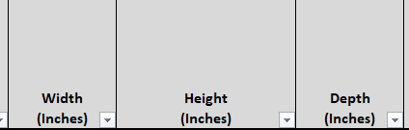
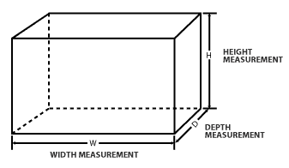

- Weight (lbs)
  - Provide the estimated weight of Kit or Part the shipment would be in pounds

- Max Reorder Quantity This is a set amount a store can reorder in a 30-day period. Can vary by part. This should be determined by the max amount of the part within the Display or store overall. This can be updated as needed while the part is active.

- Time needed to produce/ship R&M
  - Enter the number of days needed to fulfill an order. This would be the number of days it takes a part to arrive in store after receiving a PO for a new order.

- For Repair & Maintenance Orders how will the part be sent to the store
  - Will the Supplier ship this direct to store or will it be carried in by 3PL to set/install

- Does this part have any electronic components
  - This is for shipping and recycling purposes

- Supplier Name
  - Where will Purchase Orders be sent to in iSupplier to be Acknowledged and fulfilled

- Supplier Contact Email
  - Where questions should be directed to for the Display/Parts, Orders and anything else related to the VPP

- Notes
  - Add anything needing to be noted about the part line

