Beginning on January 1st, 2026, California is imposing a Covered Battery-Embedded (CBE) waste recycling fee on the retail sale of CBE products in California. A CBE product, generally, is a product containing a battery from which the battery is not designed to be easily removed with no more than commonly used household tools. If you have been sent an email advising that Best Buy’s Compliance team periodically reviews SKU setup information for accuracy, and they requested follow up on the product(s) below regarding the “contains embedded battery” attribute, please take the following actions.
- If Accurate: reply to your Category Lead and indicate why that selection was made or
- If Not Accurate: promptly update the attribute selection via PDM and advise your Category Lead when that update is complete.
Vendor partners can find the Contains Embedded Battery attribute (grouped with similar regulatory attributes) within the PDM category template:
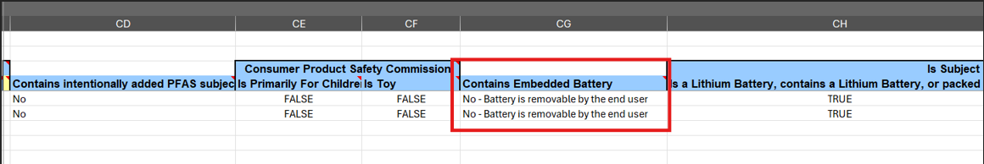
Please be aware that while we wait for a response, the product(s) is/are blocked from sale in California. We would ask you to review this information as soon as possible and reply to your Category Lead with the requested information. Once this information is received, Best Buy will remove the block from sale in California.
Questions?
Please contact PDMBusinessSupport@bestbuy.com if you have questions.

