BEST BUY CANADA LTD

Inbound Shipment Policy Guide
Version 11.3

Best Buy Canada
Suite 102 – 425 West 6th Avenue
Vancouver, BC, Canada V5Y 1L3

April 15, 2024
Contents
1. Introduction 5
1.1 Document Scope 5
1.2 High Level Requirement 5
1.3 Responsibility of Vendors 5
1.4 Vendor Compliance 5
1.5 Confidentiality Policy 6
1.6 Policy Update 6
2. Product Label Requirements 6
2.1 UPC Barcode Requirements 6
2.2 Individual/Sellable Unit Labeling 7
2.3 Master/Outer Carton Labeling 7
2.4 Cross Dock Label Requirement 8
3. Packaging Requirements 9
3.1 Packaging 9
3.2 Carton Contents 9
3.3 Carton Size & Weight Limit 9
3.4 Banding of Cartons 9
3.5 Product Packaging Industry Standard 9
4. Required Documents 9
4.1 Bill of Lading (BOL) 10
4.2 Appointment Confirmation 10
4.3 Packing Slip 11
4.4 Cross Dock Shipment Document Requirements 11
5. Shipping & Load Building Requirements 12
5.1 Palletized Load 12
5.1.1 Palletized Shipment Preparation 12
5.1.2 Palletized Product Configuration Requirements 13
5.1.3 Palletized Shipment Height Requirements 13
5.1.4 Pallet Labels 14
5.1.5 Packing Slip Placement for Palletized Loads 15
5.2 Floor Load 16
5.2.1 Floor-Loaded Shipment Preparation and Height Requirements 16
5.2.2 Floor-Load Shipment Labels 17
5.2.3 Packing Slip Placement for Floor Loads 17
5.3 Truck Loading 17
5.3.1 Truck Loading Palletized Shipments 18
5.3.2 Truck Loading Floor-Loaded Shipments 19
5.3.3 Product Damages 19
5.4 Small Parcel Courier Shipment 22
5.5 Cross Dock Shipment 22
5.6 Direct To Store (DTS) 22
6. Delivery Vehicle Requirements 23
6.1 Vehicle Size 23
6.2 Vehicle Condition 23
7. Inbound Appointment Policy 23
8. How to Book Appointments in Descartes (DAS) 24
8.1 Key Features of DAS 24
8.2 Appointment Request Layout 25
8.3 Dropdown Selections 25
8.4 Inputting PO SKU Quantity 28
8.5 Non – Auto Approved Appointments (Submitted Status) 29
8.6 Changing Appointments 29
8.7 Common Mistakes, Errors/Issues, and Validation Fails 29
9. Driver’s Responsibility 31
9.1 Steps to Follow 31
9.2 Regulations in Distribution Centre 31
10. Receiving Process at Distribution Centre 32
10.1 Inspection 32
10.2 Discrepancy Notification 32
10.3 Processing Hour Estimate 32
11. Shipping Compliance Program (SCP) 32
11.1 Program Overview 32
11.2 Vendor Responsibility on SCP 33
11.3 Performance Report 33
11.4 Compliance Expectations 33
11.5 Vendor Escalation 33
12. Holiday Volume 34
13. Corporate Contact Information 34
14. Appendix 36
Appendix A – High Level Checklist 36
Appendix B – Bill of Lading Sample 37
Appendix C – Consolidated Bill of Lading Sample 38
Appendix D – Packing Slip Sample 39
Appendix F – White Goods Vendor Fulfillment 41

Update History
Version | Date | Revisions | Page
 | July 2017 | 12. Corporate Contact Information [update: Indis Removed] | 29
 | June 2019 | Revisions to add new appointment portal, update outdated documents | Full Revision
 | September 2020 | 5.1.3 Palletized Shipment Height Requirements  12 Corporate Contact Information [update: Appointment Scheduling Desk phone number] | 13  29
V10 | June 2021 | Added Inbound Scheduling Guide (Sec 8) | Full Revision
V11 | September 2022 | 5.2.1 Floor-Loaded Shipment Preparation and Height Requirements updated 43 inches to 40 inches  11. Vendor Compliance Program -> 11. Shipping Compliance Program | 16  33
V11.1 | June 2023 | 9.2 Regulations in Distribution Centre updated with CEVA/Ingram DC requirements of ICC Bar. | 32
V11.2 | July 2023 | Updated address for K&N Edmonton DC. | 35
V11.3 | January 2024 | 9.2 Removed CEVA ICC bar requirements  12 Corporate Contact Information [update: Appointment Scheduling Desk phone number] | 16  29
V11.4 | April 2024 | 5.1.3 Update Palletized Shipment requirement for TV  5.2.1 Update Floor-Loaded Shipment Preparation for TV | 14  16

1. Introduction

1.1 Document Scope
The Inbound Shipment Policy Guide outlines all the requirements for vendors – and their carriers – to execute a Best Buy Canada Ltd purchase order. Details pertain to how products should be delivered to our Distribution centers in the most efficient, cost-effective, and secure manner for receiving, including: requesting an appointment, documentation, palletizing and loading products. The policy guide also defines the types of deliveries that are not compliant to our requirements and the criteria by which vendors are measured.

1.2 High Level Requirement
All deliveries arriving at our Distribution Centres must have an Appointment Confirmation [ref. section 4.2], be delivered as scheduled, and accompanied by the required documents. Products are labeled appropriately at both individual unit and carton levels, with matching barcode. Each load, whether palletized or floor loaded, are labeled appropriately, meet height and quality requirements, and sorted to facilitate receiving. Please see Appendix A – High Level Checklist .

1.3 Responsibility of Vendors
All Vendors are expected to adhere to the shipping requirements set forth in this guide, including ensuring that carriers, couriers and third party providers fully understand and adhere to the processes outlined in this document.

Failure to meet any requirements contained in this document will result in refusal at the vendor’s expense. All infractions will also be recorded and reported as shipment non-compliance

Scheduled appointments for shipment deliveries which are missed or late will be recorded as inbound shipment infractions, ‘Missed Appointment’ and ‘Late Arrival’ [ref. Appendix E - VCP Infraction List]. Modifications to scheduled appointments must follow the requirements outlined in section 7. to prevent ‘Missed Appointment’ or ‘Late Arrival’ infractions.

Delivery appointments are expected to be checked-in at the receiving guard shack a minimum of 15 minutes prior to the scheduled appointment time. Appointments have a 30-minute window from the designated appointment time to arrive at the DC. If the load arrives later than 30 minutes from the appointment time, it will be considered a ‘Late Arrival’ and may be refused.

1.4 Vendor Compliance
Our ultimate goal is to eliminate or, at best, minimize all logistical inefficiencies contributing to unnecessary operational costs.

Vendor Expectations:
All vendors are expected to improve their compliance rates for all infractions having an impact on operational costs in addition to Appointment Compliance. Our compliance expectations are:
- On Time compliance (Missed Appt + Late Arrival) – greater than or equal to 98%
- Load Condition & Safety compliance (Poor Load + Product Damage) – greater than or equal to 95%
- Delivery Execution compliance (shipment documentation and labeling) – greater than or equal to 95%
- Appointment Compliance rate – greater than or equal to 95%

Vendor Responsibility:
- Regularly monitor their organization’s shipping compliance via the VCP module of Best Buy Canada’s Vendor Portal;
- Conduct root cause analysis;
- Communicate and address infractions with 3rd parties such as factories and carriers

1.5 Confidentiality Policy
This document is exclusive property of Best Buy Canada Ltd. It is designed and intended for use by the vendor’s Shipping/Logistics departments. Neither the document nor the information contained within should be disclosed to others outside of your organization, with the exception of carriers, or any other groups involved in performing Best Buy Canada Ltd purchase orders.

1.6 Policy Update
This document is updated on an annual basis according to Best Buy Canada Ltd.’s fiscal year calendar to reflect any changes or additional requirements. Updates are communicated through the Partner Portal at: https://partners.bestbuy.com/canada/supply-chain-and-logistics. Any changes for your immediate attention will be communicated to your logistics and appointment scheduling contacts via e-mail.

Vendors and carriers are expected to adhere to the policy guide requirements immediately upon notification.

2. Product Label Requirements
Individual units, inner and master/outer cartons for ALL products, via all methods of shipping (including courier/small parcel), must be labeled according to the requirements below.

Information can be either pre-printed on the product/carton itself, applied in the form of a label, or a combination thereof.

2.1 UPC Barcode Requirements
Scannable UPC barcodes are mandatory for Best Buy Canada’s Distribution Centers to receive suppliers’ products, electronically and physically, into inventory.

UPC barcodes must be facing outwards to allow scanning of the barcodes at the time of receiving.

The Universal Product Code (UPC barcode) uniquely identifies the supplier, product/service, manufacturer and other vital information about the product. Based on international formatting standards – UCC-12 (North American) and EAN-13 (European) – the supplier can share product information with trading partners.

Barcode requirements:
- Clearly printed with no faded lines or numbers.
- Easily accessible without obstruction on a flat surface.
- Easily read by barcode scanners at our Distribution Centers.
- Matches the sellable unit.
[VCP infraction for non-compliance is ‘Incorrect UPC’; ref. Appendix E]

2.2 Individual/Sellable Unit Labeling
All sellable, display and promotional units destined for Best Buy Canada Ltd. stores must contain labels with:
- A scannable barcode -- UCC-12 is preferred; EAN-13 is 2nd option
- Model No. and/or product description
Floor Loaded Unit
- Labels are to be no less than 3-inches in height.
- The letter size of the information required below must be at least ¾-inch high.
- Information is to be detailed on at least two adjacent sides of every carton.

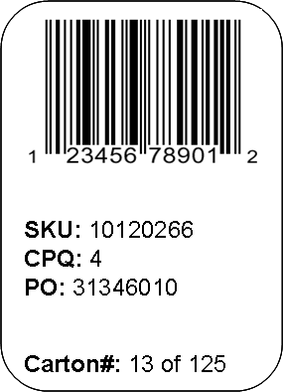
2.3 Master/Outer Carton Labeling
Master/Outer carton label sample:
Model No.: 789123
scannable UPC barcode

- Purchase Order number – clearly visible on outside of each carton
- Scannable UPC barcode – matching sellable unit
- Model No. and/or product description
- Case pack quantity (CPQ) matching quantity approved by Best Buy Canada Ltd. Merchandising
- Lot no. (i.e. 1 of 5 cartons)

Pallets containing more than one PO require carton labels on each master/outer carton:
- Inbound shipments with no labels and scannable UPC barcodes are subject to refusal. [VCP infraction is ‘Pallet or Carton Not Properly Labeled’, ref. Appendix E]
- Generic/no name carton labels are acceptable. Outer carton labels containing another retailer’s company name are unacceptable

For pallets containing only one PO and one Model No./SKU, a pallet label is required for each pallet according to the requirements outlined in section 5.1.4 Pallet Labels.

2.4 Cross Dock Label Requirement
NOTE: UCC128 labels only apply to cross dock shipments (not required for regular shipments)

- A UCC128 label must be placed on the side of each carton.
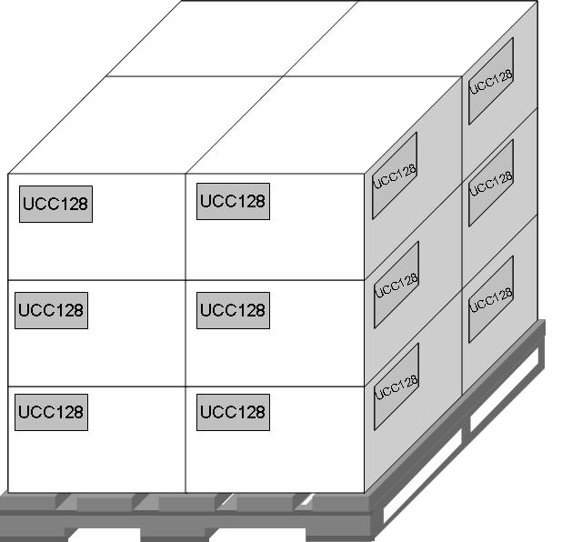

UCC128 Label Sample
All the information below must be included on the UCC128 Label:
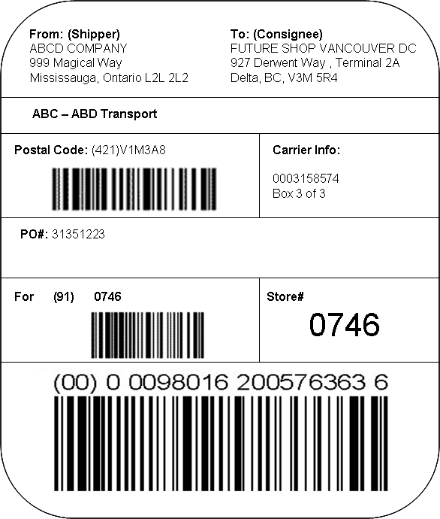

3. Packaging Requirements

3.1 Packaging
- All products must be packaged in recyclable corrugated cartons.
- ŸEach unit should be free of any excess wrap or packaging: All UPC barcodes must be scannable without removing any packaging or clear plastic when a carton is opened. [ref. VCP infraction ‘Others – See Comments’, Appendix E].

3.2 Carton Contents
- Only one model/UPC/SKU per carton:
  - Each model/UPC/SKU has a specific negotiated Case Pack Quantity (CPQ) as approved by Best Buy Canada Ltd Merchandising. [ref. VCP infraction ‘Actual Case Pack Qty Differs from Expected Case Pack Qty’, Appendix E]
- Only one purchase order per carton.
- Change requests to specific model CPQ must be sent in writing to Best Buy Canada Ltd Merchandising. If the change is accepted, the vendor can then begin shipping in the new approved CPQ for all future shipments.

3.3 Carton Size & Weight Limit
To ensure the health and safety of our receiving associates, a carton should be less than or equal to 30lbs where multiple units are shipped in one master carton. If the master carton weight exceeds 30lbs, please contact Supplychainoperations@bestbuycanada.ca for approval.

3.4 Banding of Cartons
- If bands are necessary, they must be plastic and corner protectors must be used on all the banded edges to avoid possible damage to the product.
- Unacceptable banding resulting in refused cartons at time of delivery includes: [refer to section 5.3.3 Product Damages]
  - metal banding
  - tight banding which damages products

3.5 Product Packaging Industry Standard
The Lithium Metal and Lithium Ion Batteries transportation guideline set by IATA must be followed. Please see more details at www.iata.org.

4. Required Documents
Every shipment requires a corresponding:
- Bill of Lading (BOL)
- Appointment Request Number
- Packing Slip

These documents are imperative for legal and security purposes, allowing for a smooth receiving process at our Distribution centers.

4.1 Bill of Lading (BOL)
A Bill of Lading (BOL) is a legal document issued by a carrier to a shipper, acknowledging that specified goods have been received on board as cargo for delivery to a named consignee. It is the responsibility of both the vendor and carrier to ensure the below BOL requirements are met.

All BOLs must represent/include the name of the carrier completing the physical delivery of products at our distribution centers.

Bill of Lading Requirements
- Each appointment requires its own BOL.
- The carrier must produce two copies of the BOL.
- Use one Consolidated BOL per authorized appointment when shipment consists of multiple POs.
- Multiple BOL’s for one appointment are unacceptable [VCP infraction for non-compliance is ‘Unfulfilled BOL – Multiple Sets of BOL for One Appointment’, Appendix E]
- The BOL must include:
- vendor name and contact number
- carrier name and contact number
- authorized appointment number, delivery date and delivery time
- itemized list of POs and related carton counts (per PO)
- pallet count
- Electronic (handheld) BOLs are permitted for small parcel courier shipments, but must be accompanied with a paper copy BOL. Any appointment issues/discrepancies will be recorded on the paper copy BOL.

See a sample of BOL in Appendix B and sample Consolidated BOL in Appendix C.

4.2 Appointment Confirmation
The Appointment Confirmation serves as verification that the delivery is booked and authorized by our Supply Chain Operations department. It contains the authorized appointment number, date and time, in addition to purchase order and corresponding SKU information.

Contents of Appointment Confirmation must match the actual/physical delivery. The Appointment Confirmation is the primary document used to itemize all inbound shipments and assess all discrepancies.

The Appointment Confirmation will be accepted as an alternative to the Packing Slip. All packing slip content requirements [refer to section 4.3] also apply to the Appointment Confirmation. [VCP infraction for non-compliance is ‘No Packing Slip or Appointment Confirmation’, Appendix E]

4.3 Packing Slip
The Packing Slip serves to inform all parties -- including transport agencies, government authorities, and Best Buy Canada Ltd -- of the contents of each package. All packing slips must comply with the requirements outlined below. [VCP infraction for non-compliance is ‘No Packing Slip or Appointment Confirmation’, Appendix E]

Packing Slip Requirements
- One packing slip must be presented for each purchase order on the appointment.
- All contents of a packing slip must be scheduled.
- Contents of a packing slip must match the quantity and description of the physical product being delivered.
- Handwritten revisions on a packing slip are unacceptable.
- Packing slip formatting must include Model/UPC/SKU Number
  - Quantity Shipped per Model/UPC/SKU
  - Number of Cartons per Model/UPC/SKU
- The Appointment Email Confirmation is also an acceptable document in place of a packing slip.
See a sample of Packing Slip in Appendix D. All required information is included.

4.4 Cross Dock Shipment Document Requirements
For every Cross Dock shipment, a corresponding Master List is required to replace the Packing Slip and Pallet Manifest. These are required for legal and security purposes, and to allow for a smooth receiving process at our Distribution Centres. Failure to provide these documents will result in shipping non-compliance, delayed receiving, and high risk of the shipment refusal. Cross Dock shipments also require the BOL and the Appointment Confirmation outlined in the previous sections.

Master List and Pallet Manifest Requirements
A Master List must be provided in a separate envelope or pouch and must be enclosed on the carton or pallet as shown. The Pallet Number is critical in order to assure timely receiving: please ensure that it is included in the Master List. The Pallet Manifest details the contents of the pallet.

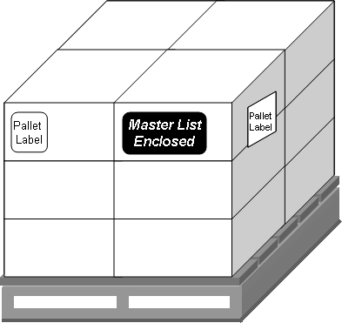
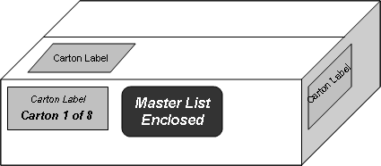

Pallet Manifest Sample Master List Sample

5. Shipping & Load Building Requirements

5.1 Palletized Load

5.1.1 Palletized Shipment Preparation
Shipments on pallets must arrive at our distribution centers according to the following requirements:

- Use 48” x 40” Stringer Class, double-face non-reversible, partial 4-way pallet made of hardwood. [VCP infraction for non-compliance is ‘Poor Load Condition - Type’, Appendix E]
- Best Buy Canada Ltd will consider pallets as non-returnable.
2 opposite ends:
stringers notched for fork entry
2 opposite ends:

- Secure in clear shrink wrap to avoid damages and ensure timely processing at the Best Buy Canada Ltd facilities. Black shrink wrap and metal banding are unacceptable.
[VCP infraction for non-compliance is ‘Poor Load Condition – Shrink Wrap’, possibly ‘Poor Load Condition – Falling Over’ or ‘Product Damage - Apparent’, Appendix E]

- Use cardboard corner boards if necessary to stabilize the pallet. The height of corner boards cannot be taller than the pallet itself.

- Standardize shipments per pallet and per trailer/truckload whereby products are stacked:
- in consistent carton quantities on each pallet (e.g. 48 cartons to a pallet)
- in uniform layers on each pallet (as shown in diagram below), secured in clear shrink wrap
- with no overhang exceeding 1 inch on each side of the pallet
[VCP infraction for non-compliance is recorded in ‘Others – See Comments’, Appendix E]

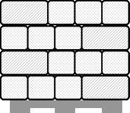
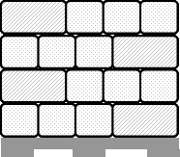
Maximum 1-inch overhang
50 in

Top View
48 in

40 in
48 in

Side View

Note: Custom pallets are acceptable when product is too large to fit on a standard pallet. Please e-mail sample photos to Supplychainoperations@bestbuycanada.ca for approval to ship on a custom pallet.

5.1.2 Palletized Product Configuration Requirements
Pallets must be configured by SKU/model, where each SKU is grouped together on the pallet, and not mixed throughout the pallet.
Where there are multiple POs for one SKU, the cartons should be grouped together so that all the POs for that SKU are on the same pallet, not mixed throughout multiple pallets.
Where there are not enough cartons of the same SKU to complete a pallet, it is acceptable to have multiple models/POs on the same pallet, so long as they are configured by SKU as outlined above. The pallet must be properly marked as “Contains Multiple models/POs”.

For Cross Dock Shipments, cartons for a single store must never be on more than one pallet except where the total number of cartons exceeds the capacity of a pallet. If multiple stores are on one pallet, stores must be grouped in numerical order. [refer to sections 2. Product Label Requirements and 5.1 Palletized Load for carton and pallet labeling requirements]
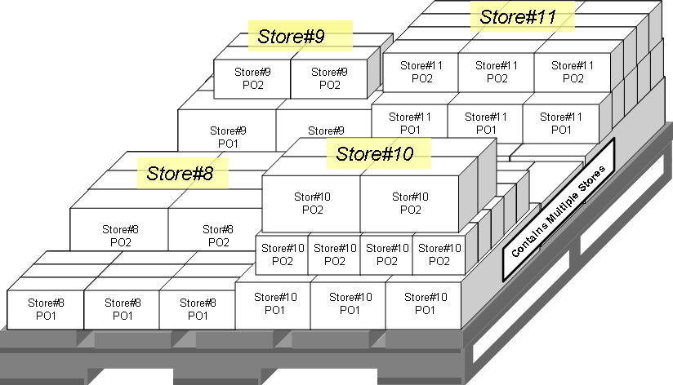

5.1.3 Palletized Shipment Height Requirements
Height of one pallet, from the floor to the top, cannot exceed 54 inches for all products, with the exception of the categories below:

Not to exceed 60 inches:
- Televisions up to 40 inches OR greater than 75 inches*  - Desktop Computers  - Printers | - Monitors  - Microwaves  - Home Comfort (Fan’s, Heaters)

Pallets cannot be stacked beyond two pallets high to minimize product damage during transportation and to ensure stability when offloading. [VCP infraction for non-compliance is ’Poor Load Condition - Height’, Appendix E]

* Televisions 40 inches and under AND 75 inches and greater must be palletized based on factory loading and transportation recommendations. Televisions between 41-74 inches must be floor loaded as indicated in section 5.2 (Floor Load)

5.1.4 Pallet Labels
Palletized loads are labeled by both pallet and carton [ref. section 2.3 Master/Outer Carton Labeling] to facilitate the receiving process at our Distribution centers.

Pallet labels are required for all inbound shipments, including those where only one PO and one SKU are on the appointment. [VCP infraction for non-compliance is ‘Pallet or Carton Not Properly Labeled’, Appendix E]

Pallet Label Sample
The information below is critical and must be included on the pallet label to ensure timely receiving:
- Purchase Order Number
- The verbiage “Pallet X of N” where X is the sequential pallet number and N is the total number of pallets per Purchase Order

When shipping a Model No./SKU on one pallet with multiple PO’s, use a label indicating the Appointment No., PO No. and Model No./SKU shown below.

1 of 3
Shipper: ABC Electronics

Appt#: 123456

PO#: 31587170
Model#: 789123
Carton Qty: 20 ctns

PO#: 31587177
Model#: 789124
Carton Qty: 30 ctns

PO#: 31587180
Model#: 789125
Carton Qty: 40 ctns

One Appt# with
Multiple PO#s and Multiple Model#s
1 of 3
Shipper: ABC Electronics

Appt#: 123456

PO#: 31587168
Model#: 789123
Carton Qty: 20 ctns

PO#: 31587168
Model#: 789124
Carton Qty: 30 ctns

PO#: 31587168
Model#: 789125
Carton Qty: 40 ctns
One Appt# with
One PO# and Multiple Model#s
1 of 2
Shipper: ABC Electronics

Appt#: 123456

PO#: 31587166
Model#: 789124
Carton Qty: 30 ctns
One Appt# with
One PO# and One Model#

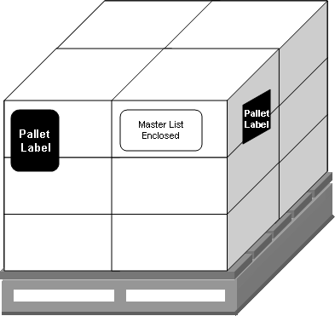
For full pallets with the same Model No./SKU, a label must be visible from all sides of the pallet as shown:

5.1.5 Packing Slip Placement for Palletized Loads
Two copies of the Packing Slip are required:

- The first copy is attached to the Bill of Lading accompanying the driver;
- The second copy is placed in a removable envelope or pouch, clearly marked as “Packing Slip Enclosed”, and attached to the actual carton/pallet per PO.

In absence of a packing slip, the Appointment Confirmation is also acceptable.

Packing Slip placement examples

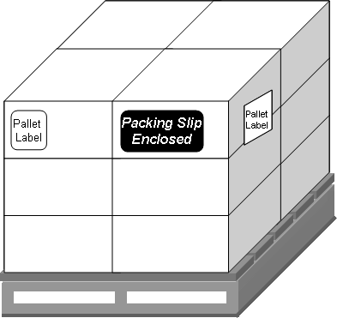
For one pallet:

For One Truckload and a Single Vendor:

Attach to the outside facing surface of the carton/pallet located at the tail end of the trailer.

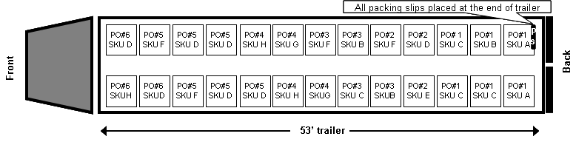

For Less-than-Truckload and Multiple Vendors (Carrier-use only):
Attach to the outside facing surface of the last pallet of that shipment.

Front
Back
53’ trailer
PO#6
SKU D
PO#6
SKU H
PO#3
SKU D
PO#3
SKU D
PO#4
SKU D
PO#4
SKU F
PS
PO#5
SKU F
PO#6
SKU D
PS
PS
PO#2
SKU G
PO#2
SKU H
PO#1
SKU F
PO#2
SKU G
PS
PO#1
SKU B
PO#1
SKU C
PS
PO#2
SKU H
PO#3
SKU D
PS
A packing slip is placed at the end trail of PO/Pallet

5.2 Floor Load

5.2.1 Floor-Loaded Shipment Preparation and Height Requirements
Products required to be floor-loaded include:

- Televisions greater than 40 inches and less than 75 inches
  - Televisions up to 40 inches AND greater than 75 inches must be palletized. Televisions between 41 ~ 74 inches must be floor loaded (section 5.1.3).
- Air Conditioners
- Bar Fridges / Wine Coolers
- Major Appliances

[Non-compliance information is recorded in VCP infraction, ‘Others – See Comments’]
Shipments loaded from the floor up in a trailer or cargo container must arrive at our distribution centres according to the following requirements:

- Black shrink wrap is unacceptable.

- Major Appliances:
- Must not be shrink-wrapped together. Where appliances need to be stacked, the bottom and top unit can be shrink-wrapped together for stability.

- Televisions:
- Shrink-wrapped in consistent bundled quantities and uniform stacks.
- Depth of TV bundles not to exceed 50 inches nor fall short of 40 inches when wrapped together. [VCP infraction for non-compliance is recorded in ‘Others - See Comments’]
- TVs must be secured to minimize shifting, falling over, and apparent damage to units. Best practices include: extra shrink-wrapping, load bars, corner boards, and uniform stacks with consistent quantities.

- Floor loaded products must not exceed 96 inches in height
- Exception: Full-sized laundry pairs which exceed 96 inches in height

5.2.2 Floor-Load Shipment Labels
Floor-loaded televisions are labeled by TV bundle/stack to facilitate a timely receiving process at our Distribution Centre.

Floor Load Label Sample

- Purchase Order number
- The verbiage “X of N” where X is the sequential TV bundle/stack number and N is the total number of TV bundles/stacks

1 of 3
Shipper: ABC Electronics

Appt#: 123456

PO#: 31587166
Model#: 789124
Qty: 30 units
One Appt# with
One PO# and One Model#
1 of 3
Shipper: ABC Electronics

Appt#: 123456

PO#: 31587168
Model#: 789123
Qty: 10 units

PO#: 31587168
Model#: 789124
Qty: 14 units

PO#: 31587168
Model#: 789125
Qty: 14 units
One Appt# with
One PO# and Multiple Model#s
1 of 7
Shipper: ABC Electronics

Appt#: 123456

PO#: 31587170
Model#: 789123
Qty: 30 units

PO#: 31587177
Model#: 789124
Qty: 28 units

PO#: 31587180
Model#: 789125
Qty: 28 units

One Appt# with
Multiple PO#s and Multiple Model#s

5.2.3 Packing Slip Placement for Floor Loads
Two copies of the Packing Slip are required:

- The first copy is attached to the Bill of Lading accompanying the driver;
- The second copy is placed in a removable envelope or pouch, clearly marked as “Packing Slip Enclosed”, and attached to the actual major appliance and/or shrink-wrapped TV bundle/stack per PO.

In absence of a packing slip, the Appointment Confirmation is also acceptable.

5.3 Truck Loading
- Loading of Brown Goods and White Goods on the same trailer is acceptable when the appointments are scheduled for the same day. The product must be loaded based on appointment time. Deliveries that are not configured by appointment time are subject to refusal.
- Exception: Loads delivering to our Edmonton and Montreal warehouses may have Brown Goods and White Goods scheduled on the same appointment.

- Both palletized and floor loaded products must be:
- properly secured in the trailer to ensure it arrives at final destination in good quality condition;
- arranged in a manner that will allow for minimal manual handling by our distribution centres

Examples of “Poor Load quality” shipments:
- shipments not properly secured causing product to spill throughout trailer.
- pallets shifted during transportation. [see infraction list Appendix E for a full list of Poor Load Condition infractions]

5.3.1 Truck Loading Palletized Shipments
- Pallets must be front-loaded straight onto trailers
- Poor Load quality shipments, side-loaded pallets, and poorly arranged loads are subject to refusal at the time of delivery.

- Side loaded pallets are unacceptable. [VCP infraction is ‘Poor Load Condition - Sideways’, Appendix E]
- Double-stacked pallet shipments are acceptable
- For loads with one appointment in a trailer, palletized products must be loaded by PO, then by model/UPC.
e.g. load all products under PO#1, then under PO#2, PO#3, etc.; load all model “A” together for each PO, then load all model “B”, etc.
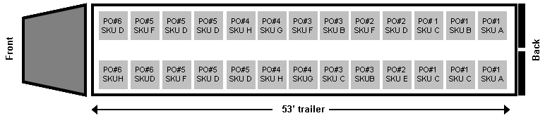

- For loads with more than one appointment in a trailer, products should be loaded by Appointment, PO, then by model/UPC
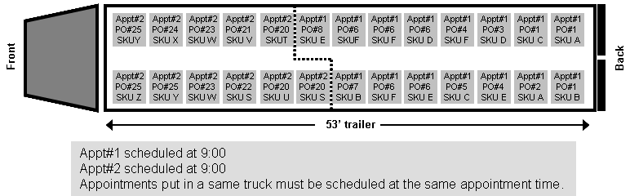

5.3.2 Truck Loading Floor-Loaded Shipments
- Prone-loaded units are unacceptable and will be refused at time of delivery.

- When loads require extra stability, shrink-wrapping the last two rows loaded onto the trailer tail is recommended to help reduce possible shifting.

- Major Appliances:
- loaded based on the loading and clamping guidelines provided by the manufacture to avoid handling damage. [ref. VCP infraction ‘Product Damage’ in Appendix E]
- loaded as individual units

- Televisions:
- single layers of TVs are unacceptable where whole units can be shrink wrapped and stacked
- load bars should be included to ensure stability of stacked TVs where necessary

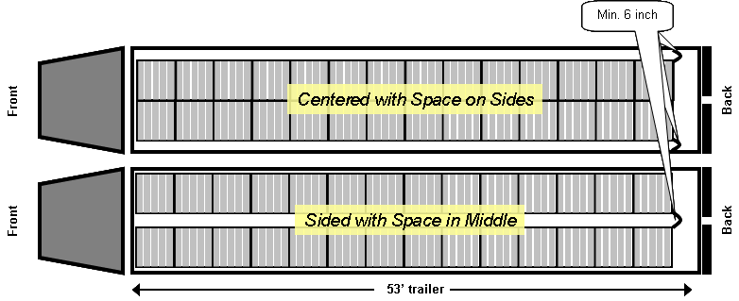
- Floor loads should be placed in the middle with space on the side, or placed right and left sides of the trailer with space in the middle to facilitate unloading with a clamp truck (see below).
Min. 2 inch

- Floor-loaded products must be loaded onto trailers by appointment, PO, then by SKU
SKU A
SKU A

SKU A

SKU A
SKU A

SKU A
SKU B

SKU B

SKU B

SKU B

SKU B
SKU C

SKU C
SKU C
SKU C
SKU C
SKU D
SKU D
SKU D
SKU E
SKU E
SKU E
SKU E
SKU E
Back
53’ trailer
Front
Acceptable:

5.3.3 Product Damages
Products must be delivered in a sellable form, acceptable to Best Buy Canada’s high quality standards and, more importantly, to customer satisfaction. Product packaging is included to assess the level of product damage – both apparent and concealed [ref. Appendix E].

Products with any carton damages found below the top two layers will result refusal of full pallet.

Unacceptable outer cartons which are subject to refusal:
- Carton holes/punctures/tears
- Cartons with water damage
- Tight banding which damages cartons
- Disfigured cartons
- Cartons with creases running top to bottom

Disfigured or fully-creased cartons indicate excessive clamping and/or exceedingly tight shrinkwrap.

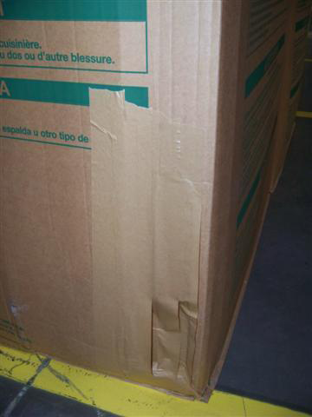  Unacceptable Holes/Punctures/Tears |  | 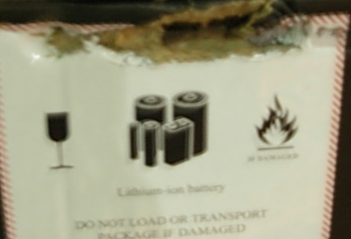  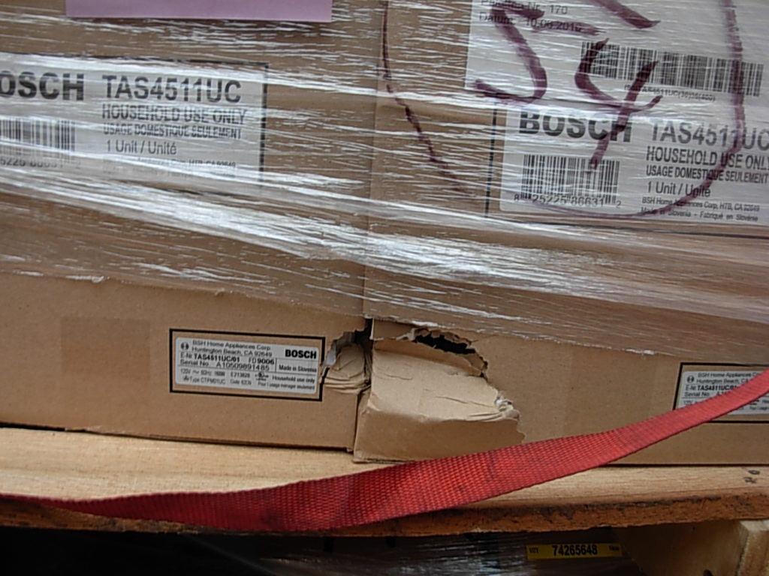
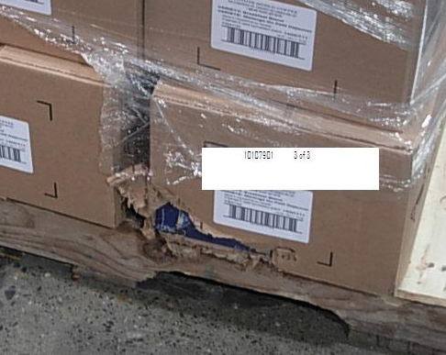

Water Damage
Disfigured and
Top-to-Bottom Creased Cartons
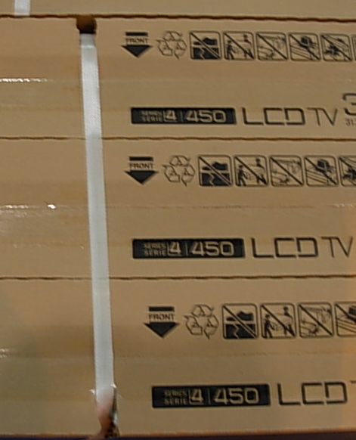  Unacceptable Cartons from Exceedingly Tight Banding |  | 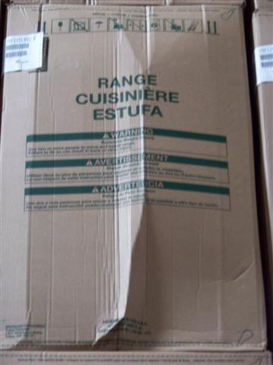
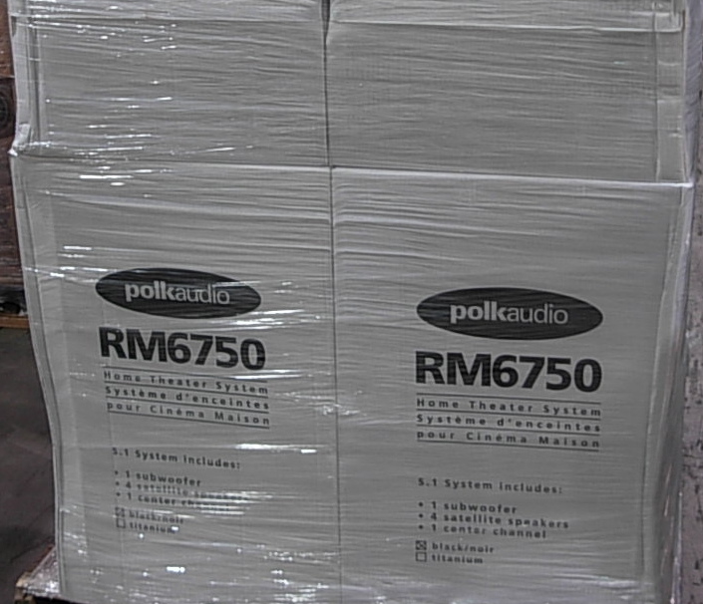 |  | 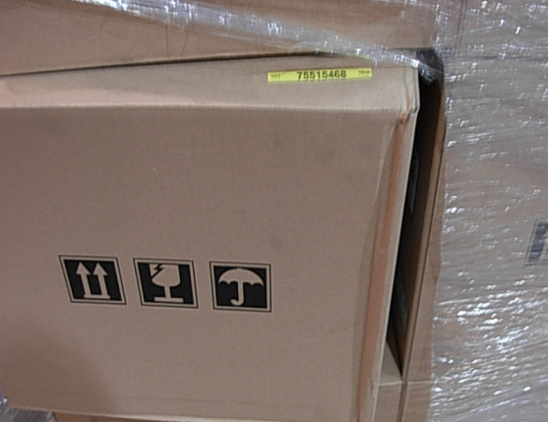

5.4 Small Parcel Courier Shipment
- As with all shipment types, appointments are also required for small parcel courier shipments:
- Courier shipments are limited to no more than 20 cartons per vendor per day
- Small parcels require a Packing Slip OR Appointment Confirmation attached to the first carton of the shipment.

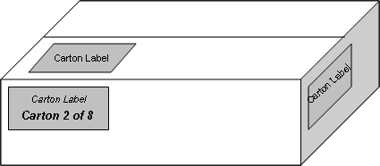
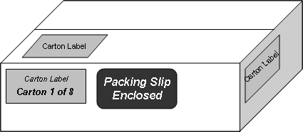

- Couriers are permitted to deliver between 6:00 am and 12:00 pm
- Courier shipments must adhere to all policies contained within this guide

- It is the courier driver’s responsibility upon delivery to:
- ensure all products are sorted and presented by purchase order on behalf of the vendor
- remain at the Distribution Centre as the delivery is detail-received
- receive any refused shipments/units, on behalf of the vendor, as noted on the driver’s paperwork

5.5 Cross Dock Shipment
A Cross Dock shipment must come with a separate Advanced Shipping Notice (ASN) for each store. Products are shipped on a pallet by store or grouped on a pallet by store so that the incoming products are loaded to outbound truck with little to no storage and handling in between.

Cross Dock is an effective and efficient way for our Distribution Centre to handle the flow of inventory. Vendors are highly encouraged to utilize the Cross Dock Process. For more information about Cross Dock, please email: Supplychainoperations@bestbuycanada.ca.

5.6 Direct To Store (DTS)
To be qualified for DTS shipments, vendors must meet certain criteria. The detailed requirements can be found in the DTS Inbound Shipment Policy. To inquire about the DTS Shipment Process, please email: Supplychainoperations@bestbuycanada.ca.

6. Delivery Vehicle Requirements

6.1 Vehicle Size
- Vehicles must be at the same level of our dock doors (51 inches).
- Any small cube vans or courier trucks must be unloaded by the driver.
- Tail gate vehicles are unacceptable.

6.2 Vehicle Condition
- Floors and walls of vehicles must be without holes or damage.
- Vehicles should be free of debris and garbage.
- If product becomes damaged during unloading due to faulty vehicle conditions, the product will be refused.
- If vehicles do not appear safe to unload, or if there is a risk of damage to the product, the shipment will be refused.
Motorized machinery of the carrier is not permitted to be stowed in the trailer for use at Best Buy Canada Distribution centers.

7. Inbound Appointment Policy
All vendors’ shipments delivering to Best Buy Canada Ltd must have an appointment number granted by our Supply Chain Operations department via our appointment scheduling portal prior to yard entry. Shipments arriving without an appointment number will be refused.

- Appointments must be scheduled through our Vendor Portal, located at https://www.services.lnos.com/DA/Default.asp
- Appointments should be made at least 72 hours prior to the requested delivery date.
- Appointments are granted based on PO delivery dates, ETA, and first available date/time.
- Appointment requests should be consolidated prior to delivery, either at the time of initial appointment submission, or by modifying an existing appointment request to add new lines to a previously-scheduled appointment.
- Appointment requests that are submitted without prior consolidation (multiple separate requests in succession that could fit onto one trailer) will be rejected so they can be consolidated into a trailer load and resubmitted.
- White Goods Vendor Fulfillment appointments must be scheduled through the Vendor Portal as a “Vendor Fulfillment” shipment type. Refer to Appendix F for detailed instructions.
- Any appointments which are late (greater than 30 minutes past the scheduled time) will be refused. [VCP infraction for non-compliance is ‘Late Arrival’, Appendix E]
- Any appointments which are missed will result in Vendor Compliance infractions and are subject to escalation to a Merchandising Director. [VCP infraction for non-compliance is ‘Missed Appt’, Appendix E]
- Any modifications or cancellations to the appointment must be submitted through our Appointment Portal at least 24 hours prior to the scheduled appointment.
- Changes to appointments that are not communicated to Supply Chain Operations will result in Vendor Compliance infractions.
- For any submissions within 24 hours of the scheduled appointment, please also alert Supplychainoperations@bestbuycanada.ca so the modification request can be approved prior to delivery.
- All vendors and carriers must be able to deliver during all hours of operation.
- One Business Day Level of Service
  - Goal is to return all valid appointment requests within one business day upon receipt of the request. The Supply Chain Operations department will process your request and provide the appointment number, date and time.

8. How to Book Appointments in Descartes (DAS)

8.1 Key Features of DAS
- Auto-scheduling feature (instant approvals)
  - Note:
    - Leaving the request time to default (midnight) will give the most visibility to the available timeslots for the requested date
    - Auto scheduling is only available for BG appointments
- Provides a Reference # upon approval
- Modifications to an appointment can be made by the requestee
  - Note: any appointments that are resubmitted will lose its original timeslot. If an appointment needs to be escalated, please contact your buyer

8.2 Appointment Request Layout
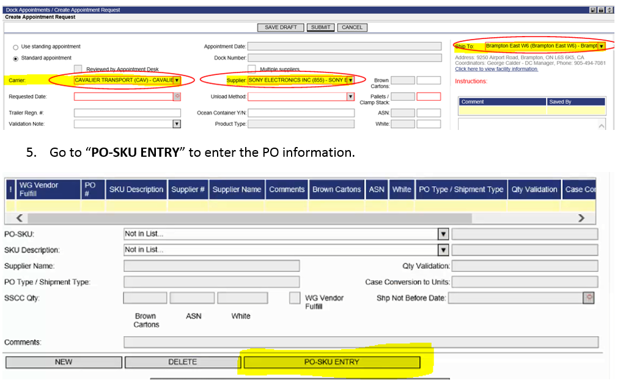

8.3 Dropdown Selections
- Carrier:
  - 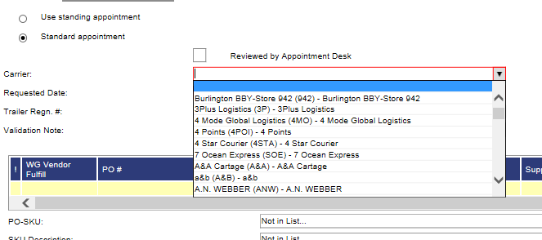
  - Choose the carrier delivering the appointment
  - If you do not see your carrier, email supplychainoperations@bestbuycanada.ca

- Supplier:
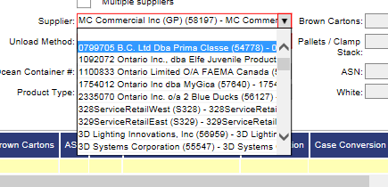
  - For vendors:
    - You should only see yourself as a vendor.
  - For carriers:
    - If you’re submitting an appointment on behalf of your vendor, choose the vendor that you’re delivering for

- Ship to:
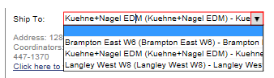
  - Select the DC that the appointment is going to

- Requested Date:
  - Select the date and time that you would like your appointment to be delivered
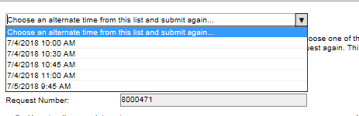
  - Note:
    - If your requested appointment date and time is not available, you will be presented with an alternate date and time.
    - Leaving the time as midnight will give you the most options for available delivery time on the date you want it delivered.
    - Please double confirm the Not Before Date (NBD) before submitting the appointment. If the appointment needs to come in before the NBD, contact your buyer to have the date revised before you submit the appointment.

- Unload Method:
  - Select the unload method that fits your appointment

Unload Method | Description
ASN xDock (please provide # of Pallets = ASN Count) | When shipment is an ASN xDock
Regular (please provide # of Pallets) | Brown Goods that are shipped in Pallets
WG Large Appliances / Furniture (Pls put 0 for Pallet / Clamp) | White Goods Appliances, Furniture, Exercise Equipment
WG TV / Stands (Pls provide # of Pallets) | White Goods TV and Stands
Courier (<= 20 Cartons) (Pls put 0 for Pallet / Clamp) | Brown Goods <= 20 Cartons
BBY/Pref Carrier (Pls provide # of Pallets) | Appointments for Best Buy Preferred Carrier
Callbacks/Adjustments | Appointments for Inventory adjustments and callbacks (BBY Use only)
Devan (Ocean Container) (Pls put 0 for Pallet / Clamp and Ocean Container #) | Ocean Containers
Vendor Credit (Pls put 0 for Pallet / Clamp) | Vendor Credit products

- Validation Note:
  - Confirm that the case pack matches the case pack in Best Buy’s syste,m
  - 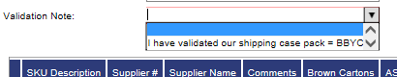

- Pallet/Clamp Stack:
  - Provide the # of pallet/Clamp stack this appointment will have
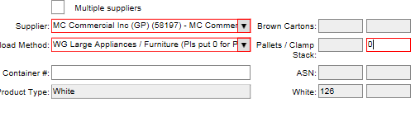
  - Note: If the appointment is a Courier (<=20 Catons), please disregard the instruction in the drop down and put in “0” as the pallet quantity

8.4 Inputting PO SKU Quantity
- Click on “PO – SKU Entry”
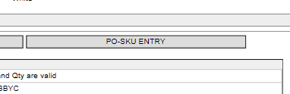
- You will be redirected to Candidate PO page
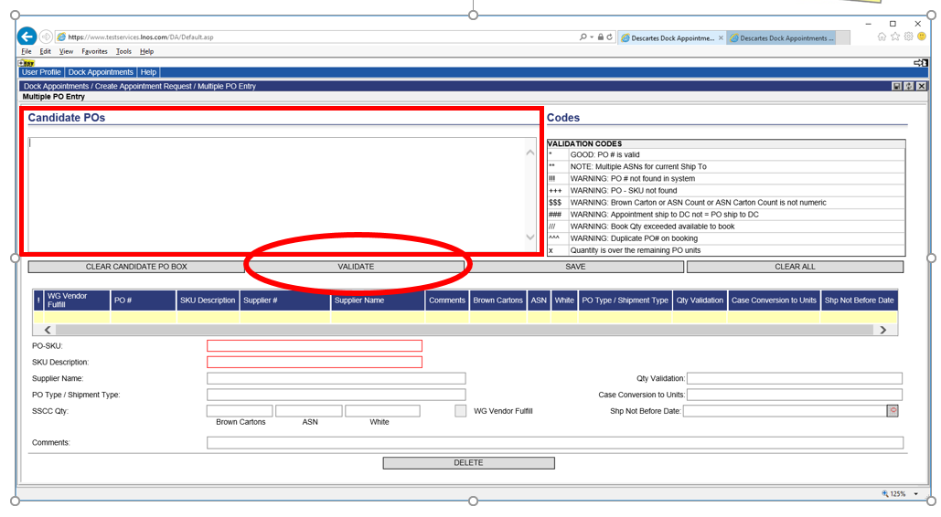
- Input the PO, SKU and Carton Qty detail in the below format
  - Please use the PO_SKU_QTY Format Generator in Best Buy Partner Portal – “CA Domestic Inbound Shipping Policy Guide (Routing and Shipping Guide)”
  - Format needs to be in ‘PO|SKU|Carton QTY’
    - Note: Each PO SKU combination needs to be a separate line.
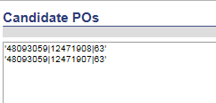

- Click “Validate” once you have completed all your PO-SKU entries
  - Validated PO-SKU will have *
  - For any errors will show a different symbol – Refer to 8.5
- Click “Save” to go back to complete appointment request
- Once all the information is filled, click “submit”

8.5 Non – Auto Approved Appointments (Submitted Status)
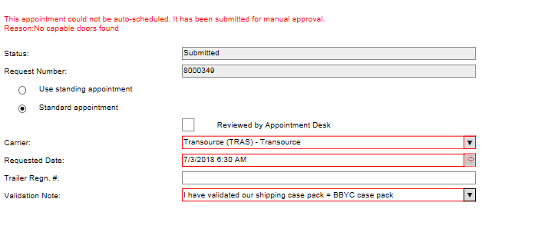
- If your appointment is not auto approved, it will remain in submitted status for the reason(s) below, but not limited to:
  - Requested date and time is not available
  - It is a WG appointment
- Manual approval needs to be reviewed by our appointment desk and will provide a response within 1 business day

8.6 Changing Appointments
- You can change your appointment to add lines, delete lines or change the date of an existing appointment
- Deleting lines: This can be done by highlighting the line you want to remove and hitting delete in the Appointment Details screen
- Adding lines: This can be done by going back to the PO-SKU entry and adding and validating the additional lines
- Changing the date: The requested date can be changed in the appointment details screen and the appointment resubmitted for approval

8.7 Common Mistakes, Errors/Issues, and Validation Fails
- When PO-SKU validation fails, please refer to the codes legend
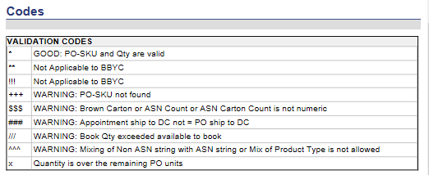
- Brown Goods (BG) and White Goods (WG) need to have separate appointment #’s
  - A single appointment # cannot have both BG and WG
- Not Before Date (NBD)
  - If you request a delivery date before the NBD on any of your requested lines, there will be an error message when you submit the appointment.
    - Please contact your buyer if you need to bring it in before the NBD
- For Appointments with BG and WG TVs:
  - For the most efficient process, do not get pre-approved appointment for BG.
  - If delivering the BG and WG on the same day, please request the BG appointment time to be earlier than the WG with a 30-minute gap
  - Leave a comment in the comment section with the WG and BG appointment #’s delivering on the same day
- WG Vendor Fulfilled (WG VF) Appointments
  - To ensure WG VF appointments can be prioritized, avoid including non WG VF and non-priority PO-SKU line items in the same appointment. Shorter appointment times are easier to accommodate
  - If there are multiple WG VF items, consolidating the WG VF PO-SKU to a single appointment request will help the appointment desk accommodate escalation and appointment request
- Appointment Submission Cutoff
  - Please submit your appointment 1 day before the requested date.
  - Each DC has a submission cutoff time
    - Brampton: 1 Day before at 10 AM Pacific Time
    - Langley: 1 Day before at 12 PM Pacific Time
    - KNN Montreal: 1 Day before at 10 AM Pacific Time
    - KNN Edmonton: 1 Day before at 10 AM Pacific Time
- Rebooking missed appointments or delivering remaining PO-SKU quantities (partially delivered appointments)
  - Any missed PO-SKU for an appointment can be booked using the same PO-SKU information with a new appointment #
  - Note:
    - If the PO is closed, contact your buyer to reinstate your PO to create the appointment
    - Quantity cannot exceed the original total quantity the PO was cut for

9. Driver’s Responsibility

9.1 Steps to Follow
- Report to guard shack a minimum of 15 minutes prior to scheduled appointment time.
- Provide BOL and Appointment Email Confirmation with Appt# to security upon arrival. Documentation for all scheduled appointments for the day must be provided. [VCP infraction for non-compliance may include ‘Unfulfilled BOL – No BOL’ or ‘No Packing Slip or Appointment Confirmation’, Appendix E]
- Please refer to the Request number on the Appointment Email Confirmation has your appointment number
- Be directed to the appropriate receiving office at the security gate.
- Bring BOL and Appointment Confirmation (or packing slips) to receiving administrator.
- Obtain Door # at the Receiving Office.
- Obtain administrator’s permission prior to driver cutting any seals or bolts.
- Have the option to be present at the time off unloading.
- Ensure his/her pump truck is secure while in the vehicle.
- Take back any damaged units in transit to the DC.
- Sign off on any discrepancies – shortages, overages, wrong product sent etc.
- Be aware that depending on the size and complexity of the delivery, there may be a wait as the DC is receiving their freight. [refer to section 10.3 Processing Hour Estimate]
- Wheels must be chocked

Please Note: The driver may be asked in some cases to correct the load (restacking, repalletizing) if compliance issues are present. Failure to do so could result in load refusal.

Courier Shipment: Upon delivery, the courier driver is responsible on behalf of vendor to ensure all products are sorted and presented by purchase order. Failure to do so may result in refusal.

9.2 Regulations in Distribution Centre
Drivers who fail to comply with DC regulations will be subject to removal from the facilities.
- Drivers must wait for appointments to be processed according to Best Buy Canada Ltd receiving procedures.
- Drivers must wait in the designated driver’s areas or can request to view the load in closer detail on the receiving dock.
- All drivers entering the DC must be escorted in by our Distribution Centre associate. Walking through the DC or dock area without an escort is prohibited.
- All drivers must wear steel toe shoes and safety vest to view the load on the receiving dock.
- Smoking is not permitted on the premises, including outside the warehouses.
- Consumer electronics are not permitted.
- Eating & drinking are only permitted in the designated areas.
- Trucks must be shut off while unloading is taking place.

10. Receiving Process at Distribution Centre

10.1 Inspection
- All the deliveries are inspected at the time of receiving – the driver may be present during this process and must remain within designated area for DC safety regulations. Failure to comply will be subject to removal from the facilities.
- Basic inspection criteria are detailed in the Vendor Compliance Program section. (See Appendix E “VCP Infraction List” in this document).

10.2 Discrepancy Notification
- Refusals and discrepancies found during the Receiving inspection are:
  - Noted on the Bill Of Lading before the driver departs
  - Recorded as inbound shipment infractions through the Vendor Compliance Program module: https://portals.qlogitek.com/bestbuyportal/Login.aspx [ref. section 10 and Appendix E]
  - Please note that the Vendor Compliance is captured in a different portal to the Appointment booking.
- Vendor claims regarding shipment discrepancies are submitted through the Finance section of the https://portals.qlogitek.com/bestbuyportal/Login.aspx. Contact Vendor Services for more information at: CASupplierInquiry@Bestbuycanada.ca

10.3 Processing Hour Estimate
The receiving processing time at our Distribution Centres depend on many aspects such as:
- Size and complexity
- Number of appointments – multiple appointments delivered on one trailer will require extra handling at the DC and increase driver wait time
- Shipping Non-Compliance– all infractions tracked under the Vendor Compliance Program affects the receiving time

The least amount of shipping non-compliance will ensure in faster receiving processing time.

11. Shipping Compliance Program (SCP)

11.1 Program Overview
Best Buy Canada Ltd works with vendors to maximize supply chain efficiencies in order to minimize operational and, ultimately, product costs. The Vendor Compliance Program evaluates each vendor’s compliance against the shipping requirements.

See Appendix E for a list of SCP infractions and definitions.

11.2 Vendor Responsibility on SCP
It is the vendor’s responsibility to:
- conduct root cause analysis;
- communicate and address infractions with 3rd parties such as factories and carriers

11.3 Performance Report
Performance Report contains:
- Total Appointments Total # of Distinct Appointments Booked.
- Total Purchase Orders Total # of Distinct Purchase Orders.
- Total SKUs Total # of Distinct SKUs.
- Non-Compliant Appointments Total # of Distinct Appointments with at least 1 Infraction.
- Total VCP Infractions Total # of Distinct Infractions
- Overall Compliance
  - % of total appointments with no infractions.
  - An appointment is considered non-compliant if there is at least 1 infraction of any level.
- On-Time Compliance
  - % of total appointments with no Late Arrival or No Show infractions.
  - Appointments coming in > 30 mins past the scheduled time and No Shows.
- Load & Safety Compliance
  - % of total appointments with no Damage or Load Condition infractions.
  - Damages and Poor Load Conditions can be of several types. See Infraction List

11.4 Compliance Expectations
As stated in the Introduction to the policy guide, all vendors are expected to improve their compliance rates for all infractions having an impact on operational costs in addition to Appointment Compliance. Our compliance expectations are:
- Overall Compliance – Greater than or equal to 95%
- On Time Compliance – Greater than or equal to 98%
- Load Condition & Safety Compliance – Greater than or equal to 95%

We are committed to fully supporting all vendors as they strive to meet compliance targets. If you need clarification about the Vendor Compliance Program or Inbound Shipment Policy Guide requirements please contact Supplychainoperations@bestbuycanada.ca

11.5 Vendor Escalation
Vendors with high infraction counts of Missed Appointments [VCP infraction is ‘Missed Appt’, Appendix E] are escalated to the Category Directors and their teams for an annual review. Escalation criteria and requirements for improvement for this year are:
- 10 of the poorest performers, across all three Tiers, with the highest Missed Appt count AND Missed Appt compliance rate at < 95%.
- Performance is reported monthly to the Customer Solutions Group. Vendors are removed from Escalation list based on results of annual review.
- If vendor performance does not improve through the course of the year, the associated Category Director will address the offending vendor, potentially with corrective measures.
Vendors with high infraction counts of Apparent Damages are also escalated to Customer Solutions Group, monitored monthly and reviewed annually. Escalation criteria includes highest Product Damage-Apparent count AND compliance rate < 95%. [VCP infraction is ‘Product Damage - Apparent’, Appendix E]

12. Holiday Volume
Best Buy Canada Ltd processes extremely high levels of inbound volume during the months from September to December each year. A separate communication will be sent to you regarding holiday volume, via Supplychainoperations@bestbuycanada.ca, on an annual basis.

13. Corporate Contact Information
Appointment Scheduling Desk
Primary (604) 412-1614
Secondary (778) 452-3711
Email Supplychainoperations@bestbuycanada.ca

Shipping Compliance
Email Supplychainoperations@bestbuycanada.ca

Cross Dock & DTS
Email Supplychainoperations@bestbuycanada.ca

Customs and Trade Compliance
Phone (612) 291-7483
Fax (612) 291-8860
Email caimportcompliance@bestbuy.com

Vendor Services
Main Desk (Accounting Claims CASupplierInquiry@Bestbuycanada.ca
information)

Vendor Agreements
Vendor Agreements (604) 419-1551
Fax (604) 412-5243
Email VendorManagement@bestbuy.com

Best Buy Canada Ltd Distribution Centres
All Distribution Centres
Primary (604) 419-1538
Secondary (604) 412-1382

- Best Buy Canada Ltd.  Western Distribution  19890 – 92A Ave  Langley, BC V1M 3A9 | 3. Best Buy Canada Ltd.  (K&N Public Distribution Centre)  Prairie Distribution  12652 - 184 Street NW  Edmonton, AB T5V 1T4  Unit 35, Building F
- Best Buy Canada Ltd.  Eastern Distribution  9200 Airport Road  Brampton, ON L6S 6G6 | 4. Best Buy Canada Ltd.  (K&N Public Distribution Centre)  Maritime Distribution  1910 Rue des Futailles  Montreal, QC H1N 2G4

14. Appendix

Appendix A – High Level Checklist

Appendix B – Bill of Lading Sample

All the information below must be included in Bill of Lading.

Vendor Contact

Bill of Lading

Ship From
ABC Canada Ltd.
788 Smith Street
Mississauga, ON, P2D 1R2
John Smith
905-111-2344

Ship To
Best Buy Canada Ltd – Brampton WH
9200 Airport Road
Brampton, ON, L6S 6G8
Appt Date
Appt Time
Ship Via
BBY Appt#
07/02/2009

10:00 AM

346930

Fast Carrier

Seal# (for truckload only)
3087662

Trailer# (for truckload only)
215-45-28

# | BBY PO Nbr | Carton Shipping
1 | 31499615 | 300
2 | 31499801 | 115
3 | 31499837 | 87
4 | 31499856 | 220
 | Total Cartons | 66

30
Total Pallet
208
Total Weight (lbs)

Appendix C – Consolidated Bill of Lading Sample

All the information below must be included in Bill of Lading.

Ship To
Ship From

Bill of Lading

Best Buy Canada Ltd – Brampton WH
9200 Airport Road
Brampton, ON, L6S 6G8
ABC Canada Ltd.
788 Smith Street
Mississauga, ON, P2D 1R2

Appointment Details
Delivery Date: _____________
Delivery Time: _____________
Appointment #: ____________

PRO # | Vendor | PO #(s) | Skid Count | Piece Count | Weight | Receiver’s Signature | Receiving  Exceptions
1551817 | Vendor A | 20031253, 21531515 | 3 | 180 | 320
1551818 | Vendor B | 22199195 | 2 | 75 | 180
1551819 | Vendor C | 23031515, 28825656, 28959595 | 1 | 35 | 120
1551820 | Vendor D | 21121211, 21131210 | 2 | 60 | 250

8 | 350 | 870

Appendix D – Packing Slip Sample

All the information below must be included in Packing Slip.

Packing Slip

Ship From
Best Buy Canada Ltd. – Brampton WH
9200 Airport Road
Brampton, ON, L6S 6G8
Ship To
ABC Canada Ltd.
788 Smith Street
Mississauga, ON, P2D 1R2

BBY PO
Ship Date
07/02/2009

31499615

BBY SKU Nbr | Description | Qty Shipping | Case Pack Qty | Carton Shipping
10051739 | Wireless Optical Mouse | 360 | 3 | 120
10065881 | USB 4GB | 1000 | 10 | 100
10102305 | Wireless Media Desktop 1000 | 80 | 1 | 80

300
Total
Carton Shipping

1440
Total
Qty Shipping

Appendix E – VCP Infraction List

Appendix F – White Goods Vendor Fulfillment

Appointment Scheduling Process

As part of Best Buy Canada’s White Goods Vendor Fulfillment (“WG VF”) initiative, this “Type of Shipment” has been made available for selection in our vendor portal.

How does a vendor identify WG VF POs?
- Vendors will be notified via EDI of any WG VF orders, and the order info will also be available in the CommerceHub OrderStream. These orders must be scheduled using the Vendor Fulfillment Type of Shipment.
- Currently, only select White Goods appliance vendors will receive WG VF POs. If you are uncertain if you are an approved vendor, please follow up with your Best Buy merchandising/inventory contact for clarification.
- No other POs should be scheduled using the Vendor Fulfillment Type of Shipment.
Can a vendor mix WG VF POs with regular WG POs?
- It is preferred to not combine Regular and WG VF PO in the same appointment.
- Under certain circumstances, appointment desk will be able to accommodate WG VF and Regular PO in the same appointment request
- Note: WG VF and Regular PO can be submitted together on the same appointment request by checking the WG Vendor Fulfill flag
What happens if I do not select the Vendor Fulfillment type of shipment?
- The appointment will still be created, but it may be scheduled outside the target window. In this event, Best Buy will follow up with the vendor to review and improve the appointment.

If you have any additional questions, please refer to the below contacts.
Regarding appointment scheduling: Supplychainoperations@bestbuycanada.ca
Regarding WG VF PO’s or other inquiries: please contact your Best Buy merchandising/inventory team.

Vendor Portal Screenshots showing Vendor Fulfillment appointment type

