Canada Reference Guide and FAQ’s

Home Page:

The home page of CAN AP Visibility has links to each screen to research your account along with the Reference Guide/FAQ (Frequently Asked Questions), Account Maintenance (adding a user) and a Message section to view any important message from Best Buy regarding system issues and/or a common tip regarding CAN AP Visibility.

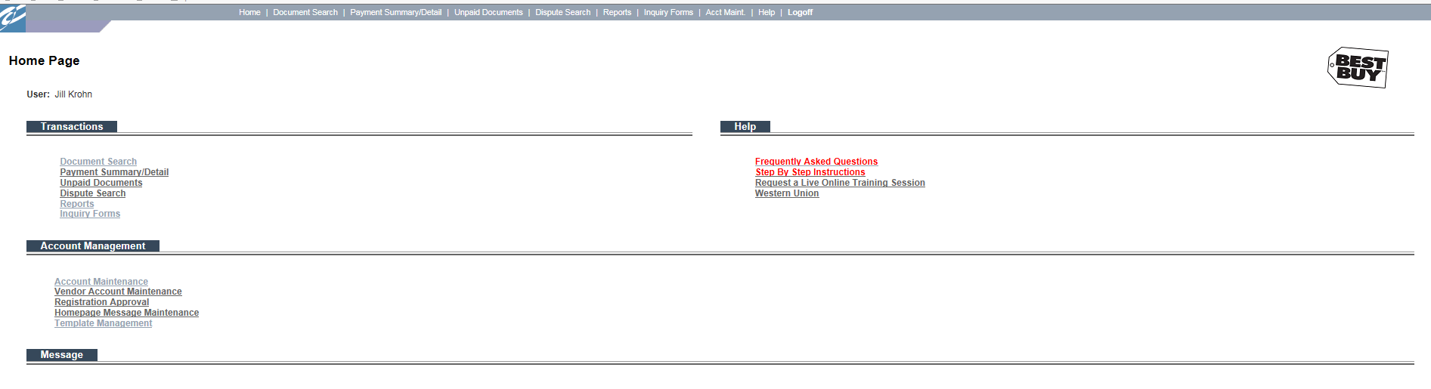

Please note in each tab on AP Visibility you will see a Step By Step guide in the upper left hand corner. This guide provides helpful instructions on how to best utilize each of the tabs.

Document Search:

Using this screen you will be able to find the status of invoices and deductions. The statuses are Paid, Pending, Unpaid or POD (Invoice payment denied due to total non-receipt). The deduction details are also available to view. You can search for invoices/deductions by the Invoice/Deduction Number, Reference Number (PO Number, RA Number, etc.), Document Type, Date Range and/or Status.
If the account is on hold, hover over the hold reason to see why and if action needs to be taken. All payment/deduction detail is available on CAN AP Visibility for 150 days from the check date. – Best Buy requires all disputes to be filed through CAN AP Visibility within 90 days of the check date.

You may also place an * asterik behind the PO number to search for the invoice status.

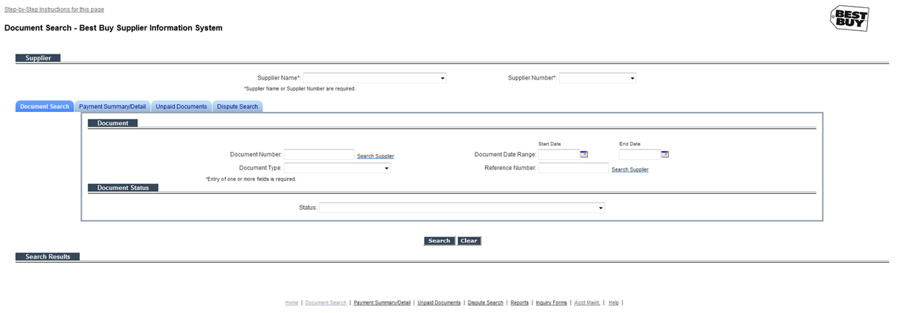

Detail of deduction:

Note: For Post Audit deduction detail the deduction number hyper link must be selected to save the backup. The detail will no longer be mailed or emailed to the vendor.

Review the detail of the deduction by selecting the hyperlink, you may Print or Export the data.
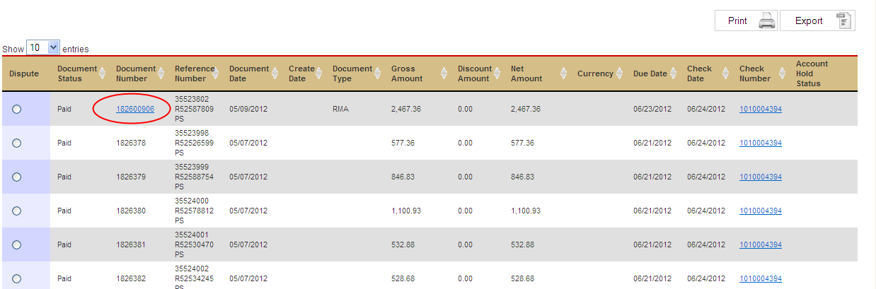

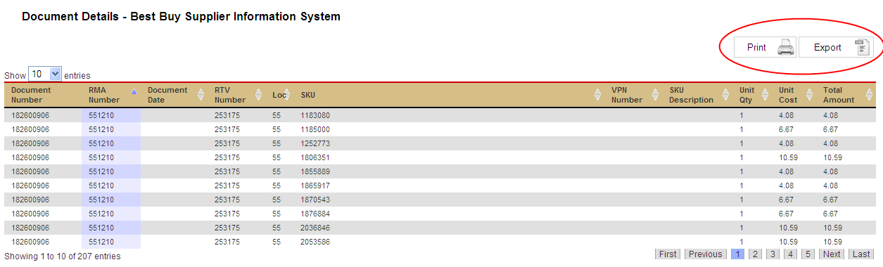

Note: If the document number does not have a ‘hyperlink’ and/or the detail is not available on the report a ‘Copy’ request form will need to be submitted.
All payment/deduction detail is available on CAN AP Visibility for 150 days from the check date. – Best Buy requires all disputes to be filed through CAN AP Visibility within 90 days of the check date.

Disputing from the document search screen

To dispute a deduction from the document search screen select the Dispute ‘radio’ button, this will route you directly to the Dispute Control Form.

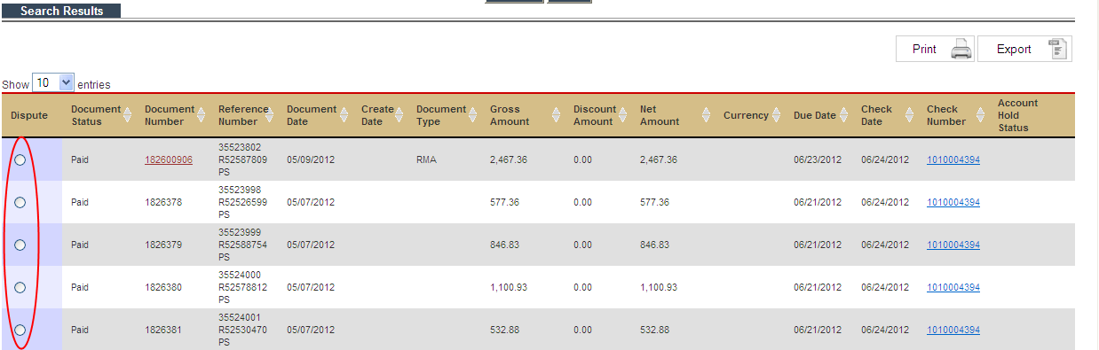

How to dispute from the dispute control form:

All payment/deduction detail is available on CAN AP Visibility for 150 days from the check date. – Best Buy requires all disputes to be filed through CAN AP Visibility within 90 days of the check date.
If the deduction is >150 days old you will not be able to dispute using the radio button, you will need to complete the ‘Deduction not Available on Site’ form.

Once you have found the document you want to dispute

- Select the Radio button
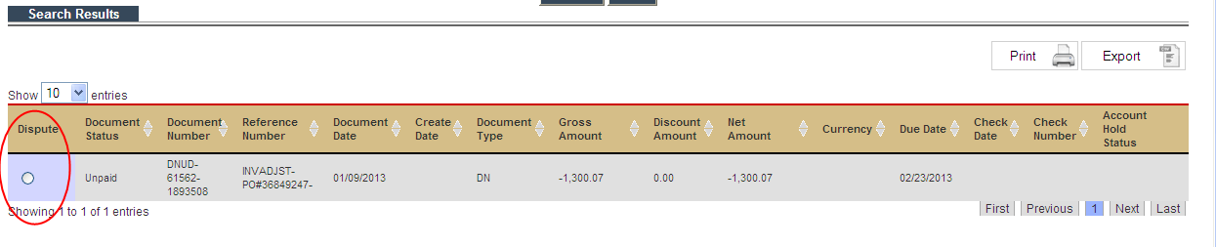

This will route to the dispute form based on the deduction type and pull in the applicable detail from the deduction that is being disputed.

*Note all RTV’s are now disputed using the RTV Dispute Grid, instructions are below.
*Note all disputes are now disputed using the Inbound Dispute Grid, instructions are below.

How to dispute from the dispute grid:

If disputing an RTV deduction, this will route you to the RTV Dispute Grid. Procedures are available below and on the Return Dispute Grid.

Note: If disputing an RTV deduction that does not contain a hyperlink the system will be routed to the copy request form. After the copy request form has been submitted a template will be sent to the requestor with instructions on how to complete the template.

If disputing a deduction, this will route you to the Inbound Dispute Grid. Procedures are available below and on the Inbound Dispute Grid.

Payment Summary/Detail:

This screen allows the ability to search for individual check remits by using the check number and/or date range of the check being issued. After selecting the radio button the detail of the check is viewable and the detail can be printed or exported to Excel. Deduction details of RTV, DNUD, DN, DNPD and PAD may also be reviewed or disputed.

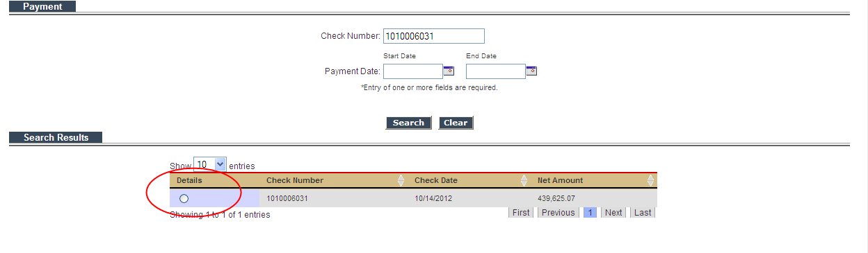

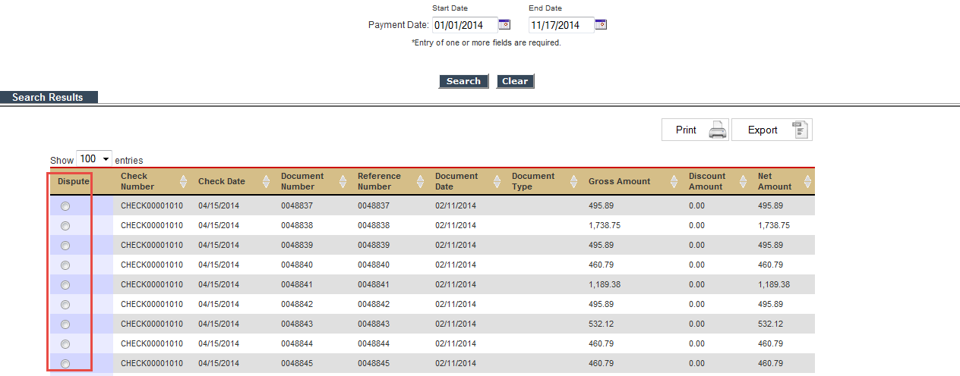

Payment/deduction detail is available on CAN AP Visibility for 150 days from the check date.

Unpaid Documents:

This screen provides documents (Invoices/Deductions) that are in an unpaid status. Search functionality is by Invoice Date Range, Due Date Range, or by selecting the All Unpaid, Current Due, Future Due. By selecting the Current Due, this will provide a list of invoices currently due and if the account is in a daily debit balance.

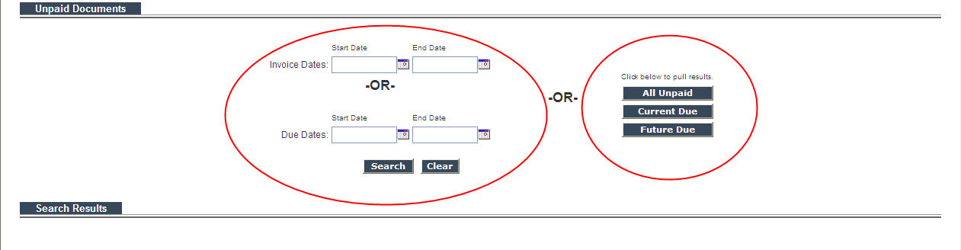

The below screen shot shows the account is in a debit balance. The print and export functionality is also available.

If a reason is in the account hold status column, hover over the reason to see why and if action needs to be taken.

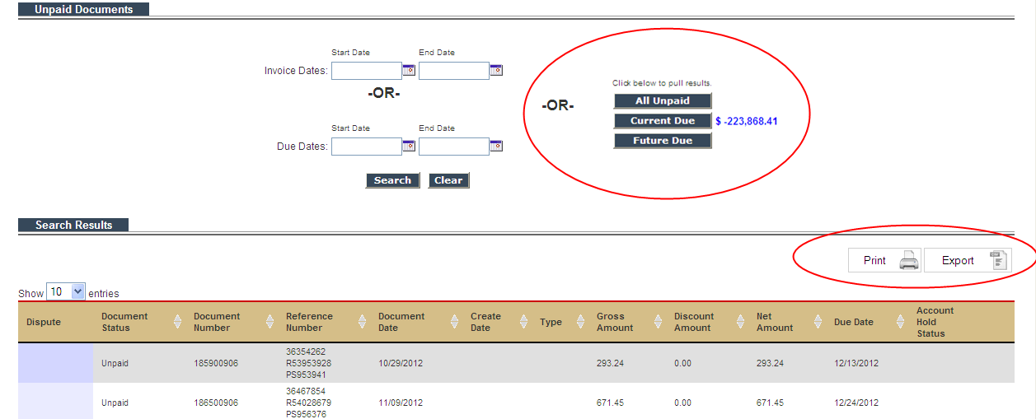

Dispute Search:

This screen allows you to review status of a deduction and/or invoice that you have disputed. You can search by dispute number, dispute type, dispute date range, BBY reference number , location and status (New, In-Progress, Approved and Closed, Denied and Closed, Partial Paid and Closed, Escalated or all).
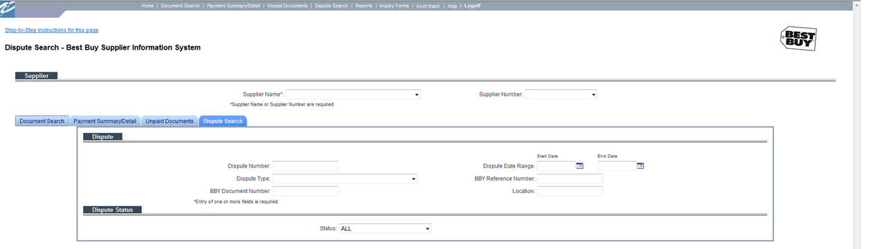

- Select: SEARCH, this will bring up high level detail of the data requested, this can be printed or exported to excel.

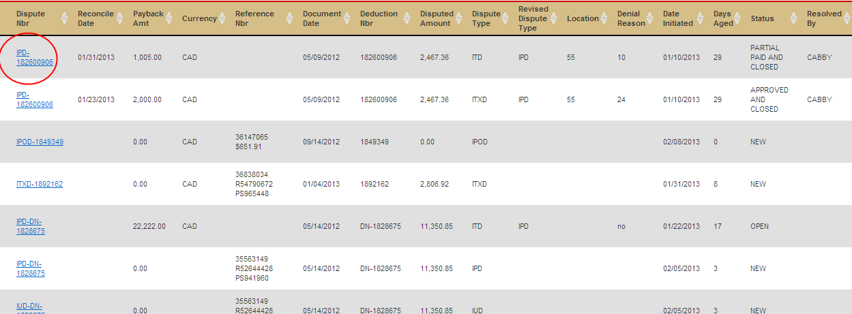

- Select: The Dispute NBR and the detail of the dispute along with the comments and BBY attachments are available if applicable.

Note: If you are looking at a dispute the detail of this will be found on the Resolution Report. (You can get to this report by clicking the hyperlink or by going to the Reports page).

Select: Return to go back to the Dispute Search screen

All dispute detail is available on CAN AP Visibility for 90 days from the reconciled date.

Reports:
This screen provides reports which will help you identify each selected items listed below.

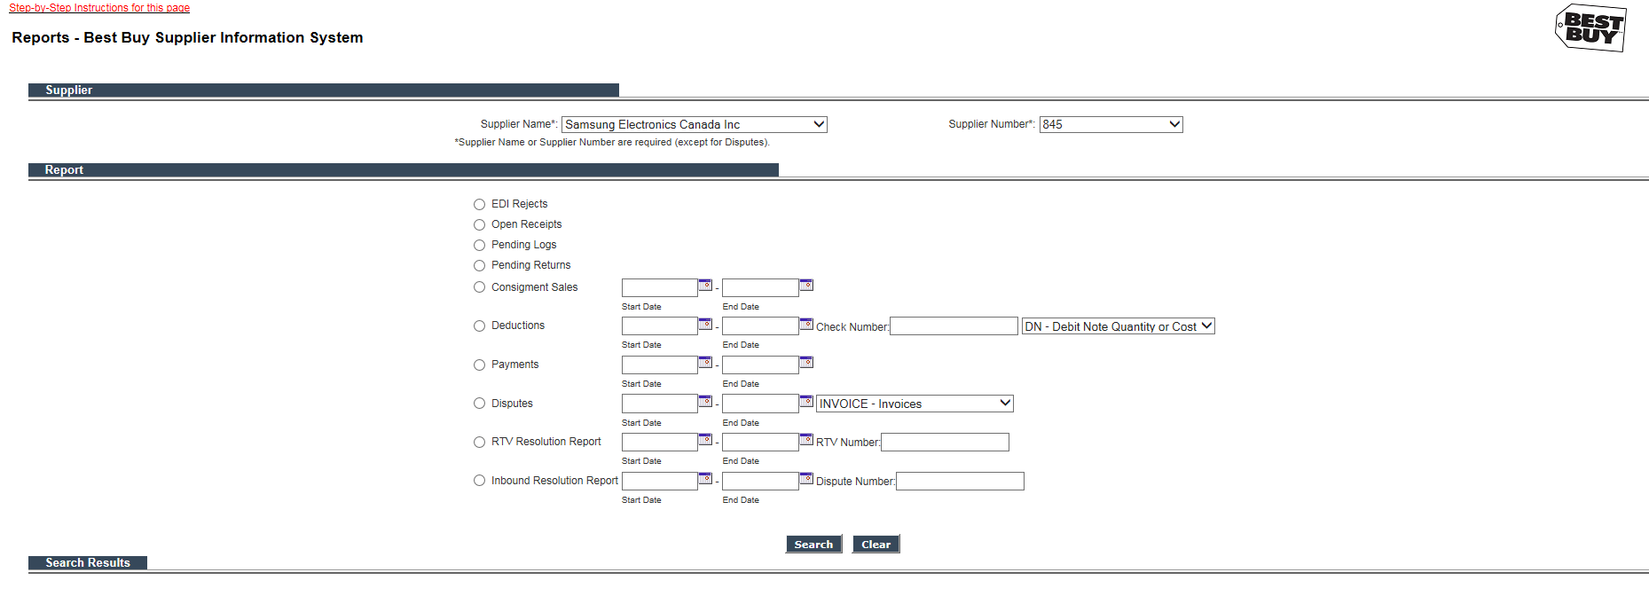

EDI Rejects: Lists all invoices that rejected and have not made it into the Best Buy Invoice matching system. Hovering over the Reason will give you information regarding the action that needs to be taken to resolve the issue.

Open Receipts: Lists receipts that are greater than 90 days old that Best Buy still shows open.

Pending Logs: If your account hold status shows “Review” you may select this radio button to review future LOG or VF deduction that is upcoming on your account

Pending Returns: If your account hold status shows “RETURN” you may select this radio button to review future RTV deduction that is upcoming on your account

Consignment Sales: Only for Consignment Vendors, report(s) detailing the consignment sales per month.

Deductions: Details of DN, PAD and RTV. Search by date range or a check

Payments: Report provides check remittance and deduction detail in 1 file, search by date range or check date

Disputes: Report of disputes filed by vendor, search by date range and selecting Document Type

RTV Resolution Report: Report of denied RTV disputes by SKU, search by date range or RTV deduction number. Hyperlink with backup will be available if applicable.

Inbound Dispute Resolution: Report of denied disputes, search by date range or deduction number. Hyperlink with backup will be available if applicable.

Inquiry Form:

This screen contains the forms to use for your inquiries to Best Buy Canada based on your question type:

- Copy Request: Use this form to request copies of deduction that are not provided on AP Visibility by the business team or are no longer available due to their age. Details of the deductions remain on CAN AP Visibility for 150 days. There is a $25.00 charge for copies of deductions that are no longer on Canada AP Visibility due to their age.
- Debit Balance Cash Receipt: Use this for to communicate method of payment that will be used to clear Debit Balance.
- Document in a Pending Status: Use this form to inquire on invoices that are in a pending status with a create date >30 days and are PAST DUE.
- Dispute Control Form: This form can be used as an alternative rather than using the ‘radio’ button on the Document Search screen. All payment/deduction detail is available on CAN AP Visibility for 150 days from the check date. – Best Buy requires all disputes to be filed through Canada AP Visibility within 90 days of the check date.
- Missing Invoice: Complete this form if past due unpaid invoices are not on the Dispute Search screen or the EDI Reject Report. Please allow 2-4 days for a response.
- Status on disputed deduction: Use this form to inquire on disputes that are unresolved and create date is > 90 days.
- Deduction not available on CAN AP Visibility: Use this form to dispute a deduction that is no longer on CAN AP Visibility due to its age. NOTE: This form should not be used to inquire on a deduction that has been partially paid back or denied. You MUST submit the Appeal Denied Dispute form if you have already disputed the deduction once. There is a $25.00 fee for each deduction that is disputed, once it is no longer on Canada AP Visibility.
- Additional Amount due to Best Buy: Use this form when additional credit is due to Best Buy Canada.
- Consignment Inquiry: Use this form to request a copy of consignment reporting as it is no longer on CAN AP Visibility due to its age. This form is also used to dispute your Consignment Sales Payment. If a vendor does not retrieve their consignment reports from CAN AP Visibility within 90 days, there is a charge of $25.00 per report.
- Appeal Denied Dispute: Use this form to appeal a dispute that Best Buy Canada has denied for pay back. All Vendors have 30 days from the reconciled date on the original dispute to appeal.
- Return Tax (RTXD): Use this template for RTV tax credit issued by vendor to Best Buy (we will deduct the RTV tax amount against vendor’s account)
- Invoice Dispute: Use this template to dispute multiple invoices with Cash Discounts, Dispute Type of ITD or select Anticipated Seasonal Dating to dispute multiple invoices for this reason.

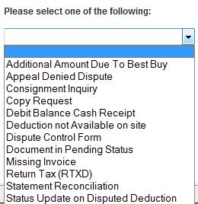

Adding additional User Login ID’s

- From the Home page select: Account Maintenance

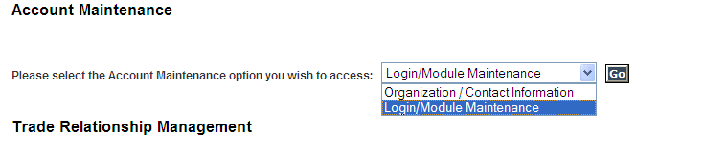
- Select: Login/Module Maintenance
- Select: Go
- Select: Add Login

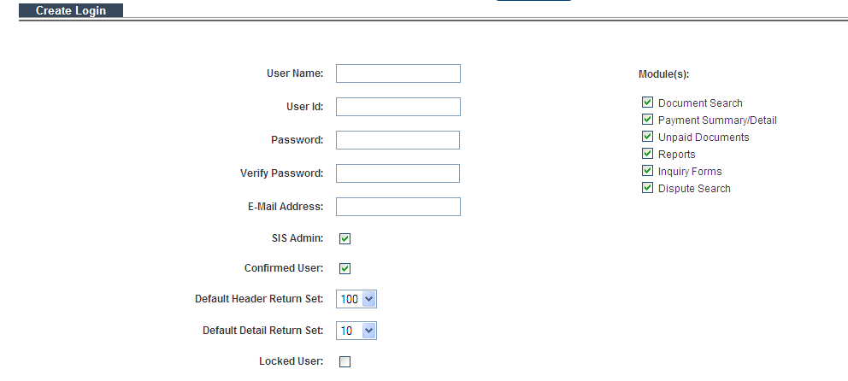
Create: New login

Best Buy Canada AP Visibility Frequently Asked Questions

Why can’t I see all my information?
Please check the Home Page for any message regarding system issues that have occurred. This message will be updated or deleted once the issue is resolved.

How current is the information on CAN AP Visibility?
The data represents the status of 1 business day prior.
Example: Best Buy’s Monday status is available Tuesday morning. Tuesday status would be available on Wednesday etc…

The delay is to facilitate the file transfers between Best Buy Canada and Easylink.

What internet explorer do I need to ensure all functionality works?
This site requires Internet Explorer 10.0 or higher

How long does the document remain in CAN AP Visibility?
All payment/deduction detail is available on CAN AP Visibility for 150 days from the check date. – Best Buy requires all disputes to be filed through CAN AP Visibility within 90 days of the check date.

How do I identify what account number the Document is under?
All the documents are located under the Payee supplier #. To figure out which supplier number a document is under follow the below steps:
- Select: Document Search
- Input: Search Criteria (Either Document Number or Reference Number)
- Select: Search Supplier
This will pull up the correct supplier the document is under.
- Select: Search to pull up results

How do I search by document number?
Select the Document Search option tab. The Document Number field is a ‘contains’ field; if you enter 123 you will get all documents that contain 123.

Using an * before and/or after the document number will pull up any document number that ‘contains’ your search criteria.
Example: DN*2* - this search will bring up any document that starts with DN and contains a 2

Can I search by more than 1 document number at a time?
Multiple document numbers can be searched at one time by separating the document numbers with a comma in the Document Number field. There is no space between the comma and second number.

After I have searched for all ‘Unpaid’ documents the line count shows that there are 1,234 documents but I am only able to see 500 of them. How do I view the rest?
To see all the documents you must select export, this will export all the documents that were found in the search results into an excel spreadsheet.

How do I search by a specific document type to limit the retrieved data?
In the document section using the drop down selection you can chose a specific document type to search by.
Example: Selecting RTV – Return RTV Deduction, this will pull up all RTV documents that are currently in CAN AP Visibility

How do I switch from one account to another to retrieve data, when both accounts are registered together?
Select supplier name you wish to search under and select new search criteria
If I search by a document number looking for a PAST DUE invoice and no data is retrieved what else can I try?

You can search using the ‘reference field’ entering the Best Buy order number. This will retrieve any invoice that Best Buy has received containing this order number. If you still do not find the invoice in the Best Buy system:
- Select: Inquiry Forms
- Select: Missing Invoice
- Complete the Missing Invoice Inquiry form and attach missing invoice template.
- Select: Submit

Note 1: If you have more than 1 Best Buy account, try searching under the other accounts prior to completing a missing invoice inquiry form.

Note 2: Submitting the Missing Invoice Inquiry form does not “transmit” the invoices into Best Buy’s system. An email is generated by CAN AP Visibility and sent to Best Buy Canada with your ‘potential’ missing invoices. We will notify you if they need to be transmitted.

Invoices in an ‘unpaid’ status and the due date in CAN AP Visibility shows they are past due, how can I research to see why they have not been paid?

- Select: Unpaid Documents link
- Select: Current Due

Is the current due a Debit amount?
Yes: Export detail and calculate due date based on current documents in the system

Is there an Account hold status?
Yes: Hover over the status for information regarding the hold

Are the above questions No?
Contact chequein@bestbuycanada.ca to find out why a payment has not been issued

The Due Dates on my unpaid invoices are incorrect, how do I inquire on them?
If the due date in AP Visibility does not match the due date you have on record you will need to validate the terms of your Purchase Order against the terms on your invoice. You will need to contact your sales team if there is a discrepancy regarding the terms.

How do I inquire on invoices that are in a ‘Pending’ status and past due?
By using the following process:
- Select: Inquiry Forms
- Select: Document in a Pending Status
- Follow instructions on how to submit your inquiry

My account is on hold due to a debit balance when will I get paid?
If your account does not have a payable balance for an extended period exceeding 30 days, you may send payment to Best Buy Canada using the following process:
- Select: Inquiry Forms
- Select: Debit Balance Cash Receipt
- Follow instructions on how to submit payment

How do I identify if Best Buy Canada received my recently transmitted invoices?
To verify if Best Buy received your invoices please review the EDI997 Functional Acknowledgement that you would have received when the invoices were transmitted. If you did not receive the EDI997 Functional Acknowledgement send an email to *IT-EDI (Best Buy Canada) edi@bestbuycanada.ca with your ISA ID, the ISA control #, the date which the invoices were transmitted and the invoice(s) numbers. They will respond to you regarding receipt of the transmission.

What is Account Hold Status?
This tells you if your account is on hold. Place your cursor over the hold reason to review the required actions needed or additional information provided to you.

What does it mean if the document number is underlined?
If you select the document number it will bring up the detail of the deduction and can be imported into Excel. Details of the deductions remain on CAN AP Visibility for 150 days.

How do I request a copy of a deduction that is not available in CAN AP Visibility?
By using the following process:
- Select: Inquiry Forms
- Select: Copy Request
- Select: Document Type
- Enter: Document number (5 per form is allowed)
Copy of a deduction that is no longer on CAN AP Visibility, there will be a $5.00 charge per copy (this does not apply to VPC’s, VF’s and LOG’s).
Note: For RTV deductions that do not have a hyperlink, selecting the radio button will redirect to the copy request form.

How do I dispute a deduction?

Note: You can only dispute a deduction/invoice 1 time for each dispute type. Make sure you are selecting the correct dispute type when you complete the form.

Note: For RTV Deductions the dispute ‘radio’ button will route to the Returns Dispute Grid. Procedures are available below and on the Return Dispute Grid.

Note: For Inbound Dispute Deductions the dispute ‘radio’ button will route to the Inbound Dispute Grid. Procedures are available below and on the Inbound Dispute Grid.

How do I dispute a deduction or invoice that is no longer on CA AP Visibility?

If the deduction is no longer available in CAN AP Visibility you will need to submit the ‘Deduction not available on Site’ dispute form located in the Inquiry Form option tab. There is a $25.00 charge per dispute for using this dispute form.

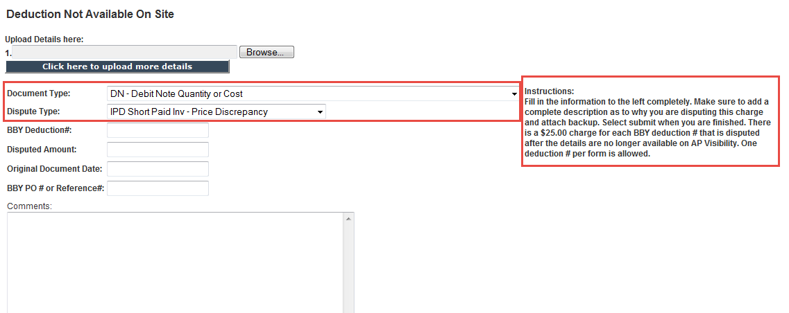

How do I dispute ITD Disallowed Cash Discount or Anticipated Seasonal Dating for multiple invoices?

- Select: Inquiry Form
- Select: Dispute Control Form, SUBMIT
- Dispute Deduction: select Invoice Dispute, SUBMIT
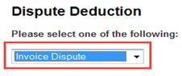
- Select: Anticipation/Seasonal Dating
Or
- Cash Discount for ITD Disallowed Cash Discount
- Complete Steps 1-5
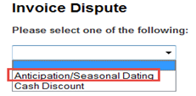

I am unable to dispute a deduction through the Inquiry Form; I’m receiving an error
“Document # is not valid.”
- Check to make sure you have entered the complete Best Buy deduction #. If you are still unable to find it,
- Select: Deduction no longer on Site form and follow instructions to submit the form.

How do I inquire on disputed deduction/invoice that I submitted over 90 days ago that is still in a New or In Progress ’ status on the Dispute Search screen?
  - Select: Inquiry Forms
  - Select: Status Update on Disputed Deduction
  - Fill in: BBY Deduction # and the disputed amount
  - Select: Submit

How do I dispute a deduction for returned product (RTV)?

- Select the dispute ‘radio’ button on the Document Search or Payment Summary screen for the Return Dispute Grid to populate.
. Procedures are available below and on the Return Dispute Grid.

If disputing an RTV deduction that does not contain a hyperlink the system will be routed to the copy request form. After the copy request form has been submitted a template will be sent to the requestor with instructions on how to complete the template.

What does the Report option tab provides?
The report screen can be used to view:
- EDI rejects – Hoover over the ‘reason’ code for details
- Receipts >90 days old
- Consignment Sales Reporting
- Deduction details for DN, PAD and RTV
- Payment detail all in 1 spreadsheet
- Disputes filed by vendor
- Pending Logs
- Pending Returns
- RTV Denied Disputes
- Denied Inbound Disputes

Where are the details for my approved or denied disputes?
Details of approved and denied disputes can be found on the Dispute Search screen
- Dispute Number: Enter Dispute # or BBY Deduction # (you may leave this field blank if you wish to review ALL of your disputes)
- Dispute Type: You may choose a dispute type or select ALL
- Status: You may leave this blank or select a status
- Select: SEARCH
- Click on the underlined Dispute # to review the details
- RTV denied disputes will contain a hyperlink to the denial report for details of the denied SKUs

My dispute was denied, how do I re-dispute it with additional backup?

- Select: Inquiry Forms
- Select: Appeal Denied Dispute
- Dispute Type: select Dispute Type that applies
Example: If deduction is related to a Post Audit, you must select PAD Post Audit Deduction
- BBY Deduction number: enter the complete deduction # or invoice number
Example: If Dispute Type is selected as PAD, BBY Deduction number should be the complete Post Audit deduction #
- Disputed Amount: enter the amount you are disputing
- BBY PO/Description: enter PO #, RMA if related to RTV or Description
- Comments: Provide additional information to support your 2nd dispute
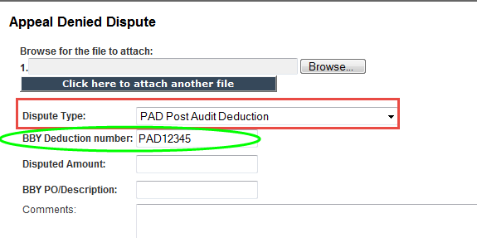

How do I know if an EDI invoice rejected?
- Select: Reports
- Select: EDI Rejects
This will provide a list of all invoices that rejected and the reject reason. Hover over the reject reason for details regarding the reject and action that needs to be taken.

If a vendor has been requested to fix and retransmit a rejected invoice and they have not complied within 30 days, Best Buy Canada will manually fix the data (if possible) and ‘push’ the invoice into the matching process. There is a charge of $25.00 per invoice with a minimum charge of $500.00 per month.

What is the Open Receipt report?
A report that contains a list of orders that have a receipt >90 days that is not attached to an invoice within the BBY invoice matching system. This report should be used to make sure that all invoices have been transmitted for the orders

We are a US vendor and our company did not register on GST/HST/QST. How do I recoup the tax?

- Using the dispute ‘radio’ button on the document search screen for the invoice that you are disputing and select dispute type: ITXD
Or
Select: Inquiry Forms
- Select: Dispute Control Form
- Select: General Dispute Form
- Enter: Document # you are disputing
- Select: ITXD
- Edit: Dispute amount if applicable
- Select: Submit

Best Buy does not include the “tax” when they deduct RTV returns, how can I issue “tax credit” for multiple RTV’s?

- Select: Inquiry Forms
- Select: Return Tax (RTXD)
- Download the template and save it to your desktop or folder
- Complete template “as is” Do NOT make changes to this template
- Column A: type your Vendor Name
- Column B: enter your Vendor Number
- Column C: enter the RTV number also known as BBY Deduction Number
- Column D: enter the RMA#
- Column E: enter the Credit Memo Total (you may also leave this blank)
- Column F: enter the GST or HST tax amount
- Column G: enter the QST or TVQ tax amount
- Column H: No actions required, total tax amount to deduct will automatically calculate as a negative dollar value
- SAVE Template, select BROWSE to upload and Submit

Please note: Best Buy does not validate the information entered on the template. The tax amount will be automatically deducted against your account based on the information provided on the template.
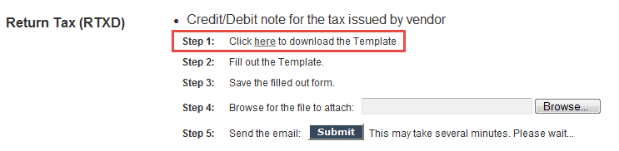

General Inquiries
- Consignment Inquiry: Canadaconsignment@bestbuycanada.ca

- Post Audit Inquiry: PostAudit@bestbuy.com

- Log and VF Deduction Copies or Questions: Vendor.Support-Acct@bestbuy.com

- Inquiry on Registration Numbers PST/GST/HST/QST: Gurmisangha@bestbuycanada.ca

- Questions with Scheduling Shipments, Delivery Appointments or Cancellation: supplychainoperations@bestbuycanada.ca

- Inquiry regarding Western Union or check remits: epayvendormanagement@westernunion.com

- RA Reports should be sent to: RTVLiaison@Bestbuycanada.ca

- Non Merchandise Invoice, Payment or Questions: acs@bestbuycanada.ca

- Vendor Account Hold: ChequeInquiry@Bestbuycanada.ca

- Vendor account address change, name change or contact changes: Vendorsetup_Programs@Bestbuycanada.ca

- Debit Balance Inquiry: debitbalance@bestbuycanada.ca

- Cash Discount Inquiry: chequein@bestbuycanada.ca

- Rejected EDI Invoices: edireject@bestbuycanada.ca

- All other inquiries should be done through AP Visibility, if you need assistance contact CASupplierInquiry@Bestbuycanada.ca

