AP Visibility Registration

AP visibility is the only method available for viewing accounting details and filing claims. Please follow instructions below to set up your account.

BEFORE YOU START: In order to set up in AP visibility you need your 3-5 digit vendor code (OFIN code). In case you do not have it, please send an email to casupplierinquiry@bestbuycanada.ca
- Fill out the application on: https://www.enabletrading.com/sscripts100B/tg_prod.wsp/reg.htm

Note: The above information is used only to get you through the registration process. Information should be for the person that is going to be the AP Visibility administrator for the account.
- Fill in: Organization Shipping Address
- Fill in: Organization Billing Address or check the box if the shipping and billing address is the same
- Select: Next

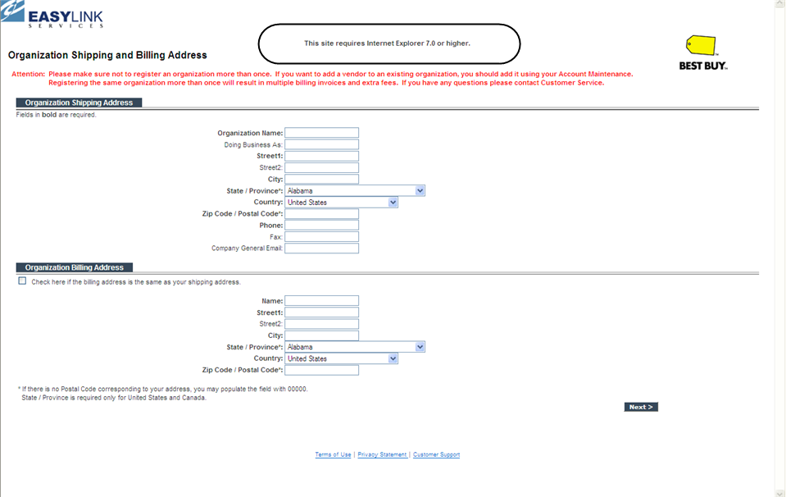

Note: The below information should be the person that is going to be your AP Visibility system administrator.

- Enter: Organization Contact Information
- Enter: Secondary Contact if applicable
- Enter: Billing contact; this is for registration purposes only there is no charge to use AP Visibility
- Select: Next

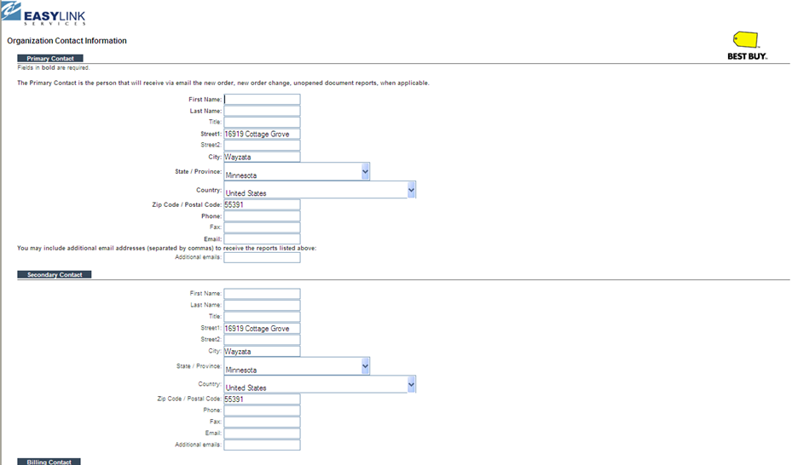
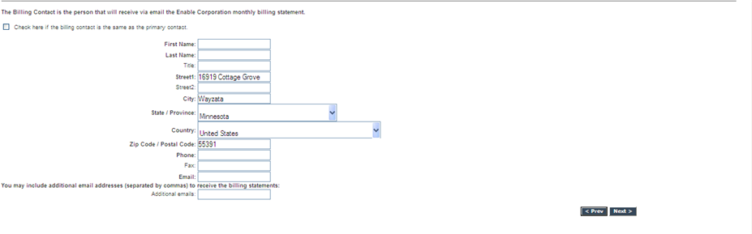

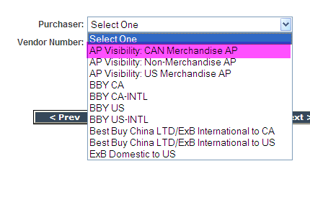

- Merch vendors - Select: AP Visibility: CAN Merchandise AP – DO NOT SELECT BBY CA
- Non – Merch Vendors – Select: AP Visibility: Non-Merchandise AP
- Enter: Your account - 3 to5 digit number provided to you in your ‘Welcome to Best Buy’ letter (included in subject line of this email).
- Select: All search screens
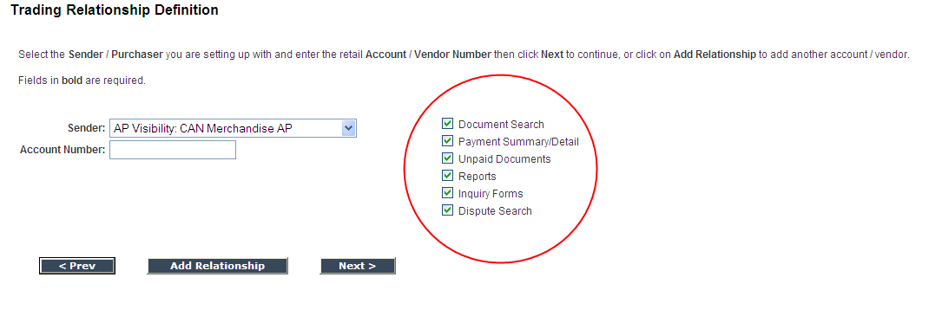

- If you have additional accounts

  - Select: AP Visibility: CAN Merchandise AP
  - Enter the next account number
  - Select: Add Relationship until you have added all your accounts

- Select: Next
NOTE: This is a free service provide to our vendors, this information is needed just to get through the registration process.
- Enter Promotion Code: BBYSIS
- Select: Check or Money Order ( By entering the information in this format, the organization will bypass any fees)

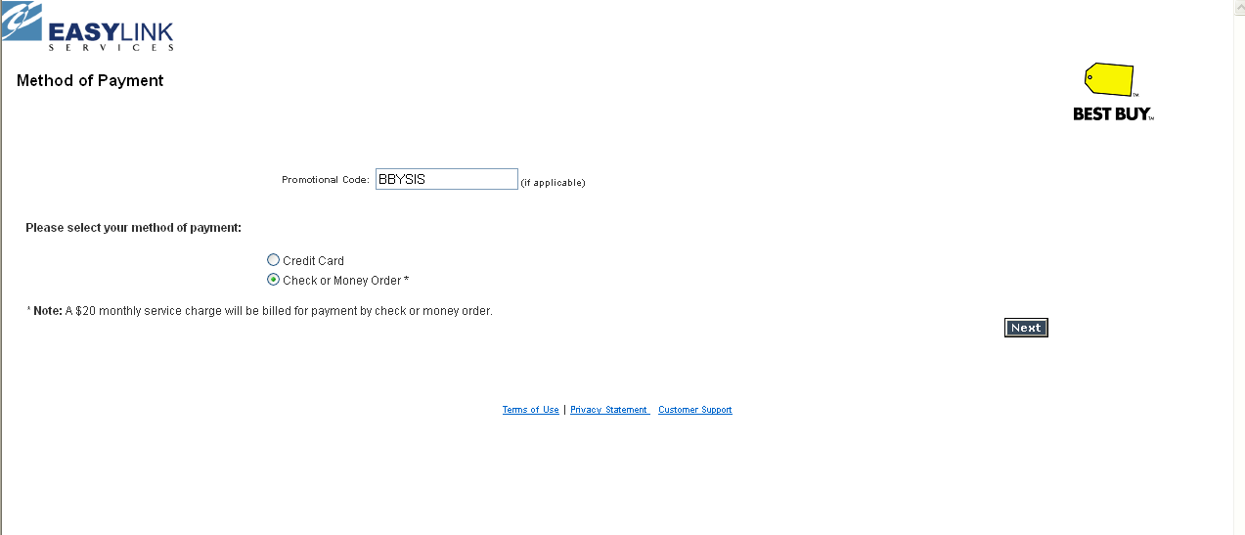

- Select: Next

- Create User Name: (suggestion enter “Organization Name”)
- User ID (suggestion enter Users First Initial and Last Name)
  - When receive access, this will be your login ID (or user name). Password will be generated and sent in email once you are approved.

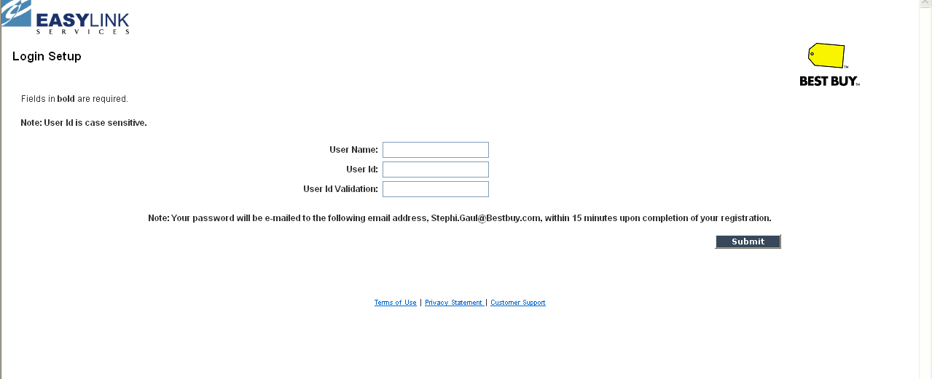

- Select: Submit

- Registration is complete message:

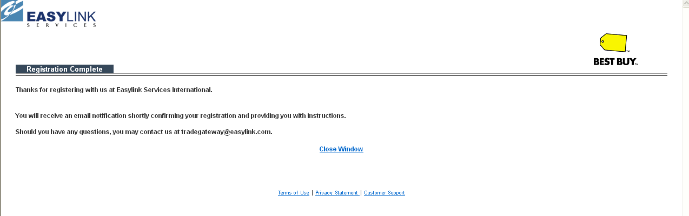

An email will be sent to Best Buy to validate and approve registration. You will receive an email from Easylink once the registration has been approved which will include your temporary password.

Once you have received confirmation that your account has been activated you can add other users
- From the home page select: Account Maintenance
- From drop down select: Login/Module Maintenance and select go
- Select: Login

Go to account maintenance and select ‘Add Login’ if you have further questions contact EasyLink Customer Support.

If you already have an account with Easylink:

Select: https://www.enabletrading.com/scripts/tg_prod.wsp/logon.htm
From Home page on EasyLink
- Select: Account Management section
- Select: Account Maintenance

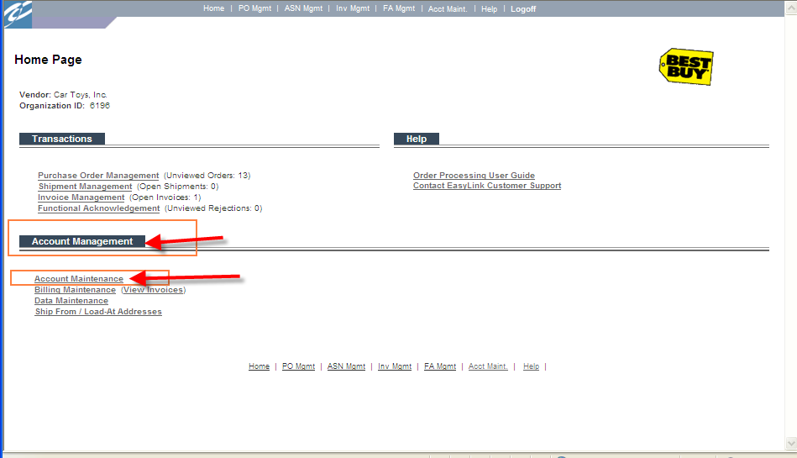
At the Trade Relationship Management window, scroll down to the bottom of the screenSelect: Register For Another Best Buy Corporate Entity 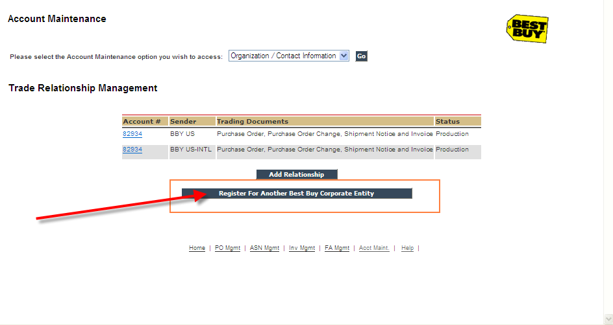
From the Purchaser list select: AP Visibility: CA Merchandise AP
Enter the account number that you want registered for AP Visibility. This step will need to be done for each account that you want registered for AP Visibility.
If you have any problems registering your accounts, contact: tradegateway@opentext.com.
Once you have received confirmation that your account has been activated you can add other users
- From the home page select: Account Maintenance
- From drop down select: Login/Module Maintenance and select go
- Select: Login

Go to account maintenance and select ‘Add Login’ if you have further questions contact EasyLink Customer Support.

